AMC Aspermont European Equity Rotator Basket
Product update as September 30, 2026
Certificate price (September 30, 2026): EUR 167.69 monthly performance: -2.71%, YTD: 6.45%, since inception: +94.17%

The Aspermont European Equity Rotator Basket
The Actively Managed Certificate (AMC) linked to the Aspermont European Equity Rotator Basket gives investors the opportunity to invest in a dynamic, broadly diversified European equity portfolio. Since investments are made exclusively in indices, stock-specific risks are eliminated. The strategy is designed to give the manager the opportunity to add direct sector exposure by under/OWing specific segment compared to index weight. Target weightings are determined by both fundamental and technical aspects and are continuously reviewed and adjusted as necessary. We place emphasis on the relative strength indicator (RSI), which is a technical momentum indicator that compares the magnitude of recent gains to recent losses of the asset to identify overbought and oversold conditions.

Manager’s Comment
European stock markets had a weak month in September, although hope remains for a possible end to the conflict, renewed tensions weighed on the markets. The broader STOXX Europe 600 Index was down -2.49%. The Aspermont European Rotator Basket during September underperformed the Stoxx 600 with a return of -2.71%. At the end of the month, the basket was invested across 19 European sectors, holding a cash position of 0.01%.  Amongst general market weakness, technology was the strongest-performing sector in September, gaining +5.0% and contributing +0.54%; during the month we increased Technology from Neutral to +1%. We decided on the OW as the sector recovered from concerns around increasing Chinese competition for ASML and renewed strengthening of AI-driven chip demand. Banks was our top OW position in September and declined -1.7%, less than the broader market. During the month we increased to +5% OW based on expectations that higher interest rates would remain supportive for the sector as it boost their net interest margin. Our other OW position, Industrial Goods & Services performed -3.2%, weaker than the broader market as rising yields, inflation concerns and profit-taking outweighed strong structural demand for defence, aerospace and AI related topics such as electrification and data-centre investments.  Several of our defensive positioning decisions helped limit the impact of the broader decline. The existing -5% UW in Automobiles & Parts was beneficial as the sector fell -8.5%, limiting its contribution to -0.14%. Our -2.5% UW in Personal & Household Goods also reduced exposure to a sector that declined -9.2%. Real Estate was reduced close to zero during the month ( -7.9% perf), Media was also reduced close to zero (-3.7% perf). We reduced Health Care to -1% UW because of concerns around expiring patents and weaker innovation, also limiting the impact of the weak sector in September (-3.8% perf). Oil & Gas also performed positively, gaining +1.60% and contributing +0.08%, while Personal Care, Drug & Grocery Stores gained +2.03%.. |  | 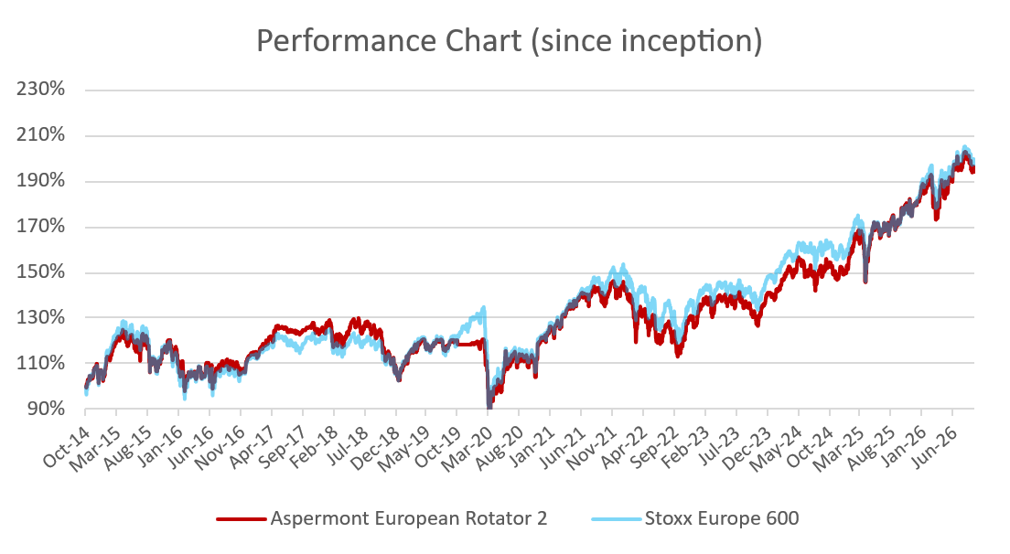  Performance since launch vs. STOXX Europe 600 (rebased)  Source: Bloomberg  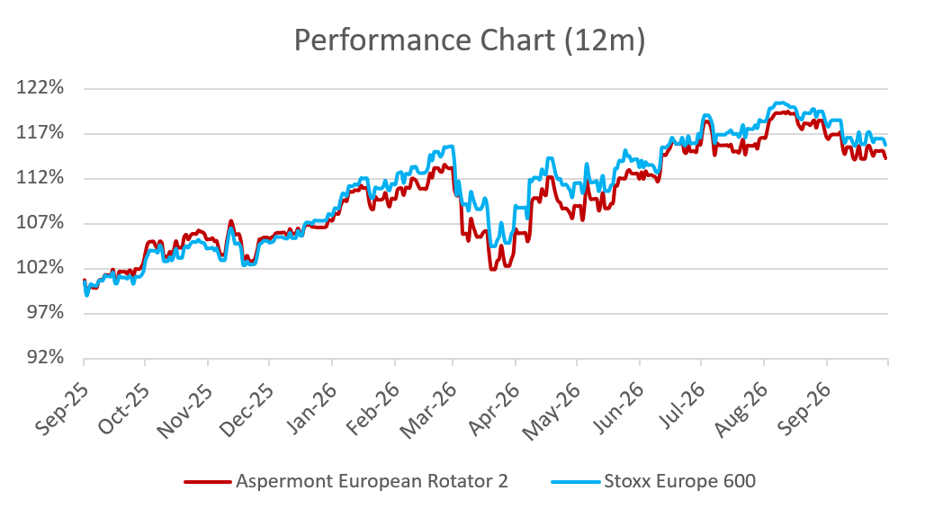  AMC 12m performance vs. STOXX Europe 600 (rebased)  Source: Bloomberg

Returns
 | Jan | Feb | Mar | Apr | May | Jun | Jul | Aug | Sep | Oct | Nov | Dec | YTD
2014 |  |  |  |  |  |  |  |  |  | 4.62% | 3.56% | -2.36% | 5.79%
2015 | 5.76% | 5.48% | 2.51% | -1.43% | 0.81% | -4.62% | 4.32% | -6.23% | -3.23% | 6.70% | 3.93% | -3.49% | 9.85%
2016 | -4.37% | -5.35% | 0.26% | 0.54% | 3.75% | -5.06% | 4.45% | 0.02% | 0.66% | -1.58% | -0.63 | 5.57% | -2.00%
2017 | -1.25% | 3.77% | 4.26% | 1.98% | 1.27% | -1.45% | -0.04% | -0.27% | 1.62% | 1.62% | -2.31% | -0.65% | 8.40%
2018 | 2.61% | -3.34% | -2.36% | 4.38% | 0.90% | -1.26% | 2.68% | -1.91% | -1.10% | -7.80% | -2.50% | -5.64% | -14.90%
2019 | 5.57% | 4.01% | 1.00% | 3.69% | -4.25% | 3.18% | 0.00% | -0.81% | 1.61% | -1.57% | 0.00% | 0.09% | 14.50%
2020 | -1.77% | -6.11% | -11.8% | 5.32% | 4.81% | 3.31% | -1.47% | 3.28% | -1.53% | -5.46% | 15.6% | 2.59% | 4.21%
2021 | -1.88% | 3.40% | 5.93% | 2.31% | 1.94% | 0.90% | 0.55% | 1.71% | -4.15% | 4.10% | -2.30% | 3.81% | 16.63%
2022 | -3.45% | -4.87% | 0.16% | -1.97% | 0.22% | -7.80% | 5.52% | -4.50% | -5.48% | 6.15% | 7.29% | -1.97% | -11.38%
2023 | 6.27% | 1.25% | -0.16% | 1.59% | -2.96% | 3.13% | 1.51% | -3.25% | -3.06% | -3:43% | 7.37% | 3.27% | 10.37%
2024 | 1.22% | 2.76% | 4.22% | -1.58% | 2.36% | -3.61% | 1.47% | 1.52% | 0.99% | -3.31% | -0.22% | 1.02% | 6.74%
2025 | 6.91% | 3.12% | -3.14% | 1.06% | 4.77% | -1.11% | 1.23% | 0.33% | 2.20% | 2.49% | 0.18% | 1.80% | 21.30%
2026 | 2.24% | 3.09% | -8.35% | 5.06% | 3.30% | 3.50% | 0.05% | 0.77% | -2.71% |  |  |  | 6.45%

Figures & Ratios
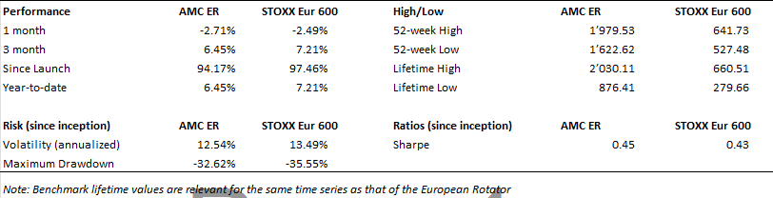
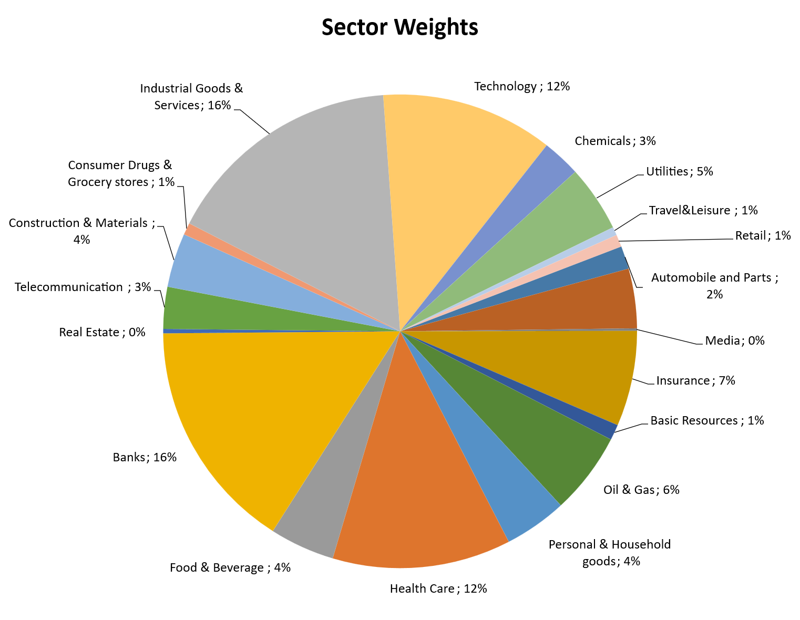
Certificate Terms  Issuer: UBS AG, Zurich  Investment Manager: Aspermont Capital AG  ISIN: CH0473592290  Profile: Tracker-Certificate (SVSP-Code: 1300)  Launch date: December 09, 2019 | ..  Currency: EUR  Denomination: EUR 1000 per Unit  Maturity date: December 09, 2026  Listing: None  (Original launch October 20, 2014)

