AMC Aspermont Dividend Stock Basket
Product update as of September 30, 2026
NAV per share (September 30, 2026): EUR 218.73, monthly performance: -1.46%, YTD: 11.01%, since inception: +118.29%

The Aspermont Dividend Stock Basket
The Actively Managed (Strategy) Certificate (AMC) linked to the Aspermont Capital Dividend Stock Basket provides investors access to a broadly diversified portfolio of around 30 attractive value stocks. We particularly seek out companies with stable or growing dividends and payout ratios, driven by healthy balance sheet structures and sustainable revenue and earnings growth. While screening for such quantitative elements as margin growth, free cash flow and debt-to-equity ratios, qualitative aspects like management performance and corporate strategy are also included in our selection process. A minimum of 80% of the portfolio will be invested in large cap names with market capitalizations of over EUR 10 billion.
Manager’s Comment
In September, the Dividend Basket delivered a -1.46% performance. The conflict is still ongoing and the and the major markets had mixed performance: DAX -4.03%, Eurostoxx 50 -2.35%, SMI -3.19%, S&P500 -0.45%. In general, we continued with overall USD exposure of around 18%. The USD has been weak in the past months and in August it strengthened against the EUR with +2.45%.  Technology-related holdings provided some of the strongest positive contributions. VAT Group (2.7% position) gained +12.31% and contributed +0.30%, this was supported by strong AI-driven wafer-fab investment and a record order backlog for the company. ASML (2.7% position) rose +9.90% and added +0.24% also driven by AI, in their case a strong rebound for AI-driven chip demand. Microsoft (3.5% position) gained +3.31% and contributed +0.11% with continued enthusiasm for AI and Azure growth; they continue to invested heavily in data-centers and their Copilot expansion. Nokia (2.7% position) rose +3.26% and added +0.08% profited from the expanded Microsoft partnership and continues to benefit from strong AI and cloud enthusiasm in the markets. Among the larger 5% positions, Apple (5.0% position) was the strongest performer, gaining +7.81% and contributing +0.36% with the announvement of their Siri AI and iOS 27 rollout that sparked renewed confidence in Apple Intelligence. PKO Bank Polski (5.1% position) gained +1.89% and added +0.09%.  On the negative side, Hermès was the largest detractor, falling -16.90% and subtracting -0.50%, amid our concerns around weak Chinese consumer demand. Inditex declined -7.21% and detracted -0.38%, while Morgan Stanley fell -9.91% and contributed -0.29%. Among the other approximately 5% positions, Enel (-4.46%), Siemens (-3.62%), ABB (-3.44%) and Banco Santander (-2.67%) detracted -0.23%, -0.19%, -0.17% and -0.13%, respectively. Anheuser-Busch InBev declined -4.98% and detracted -0.15%.  Portfolio activity remained active during the month. We increased Schneider Electric, ABB, PKO Bank Polski, Enel and Linde to approximately 5%, while EMS-Chemie was increased to 2.5%. At the same time, Nestlé was reduced to 1%, Austrian Post and Bolloré were exited, and Hermès and Anheuser-Busch InBev were reduced to 2.5% and 3%, respectively. Vinci and Veolia were also reduced as we lowered French exposure, while Microsoft and Morgan Stanley were reduced to approximately 2.5% to take profits and lower USD exposure. Apple and Banco Santander were brought back toward 5% through profit taking. Schneider was increased on the back of solid large-scale projects and cash generation, while EMS-Chemie continued to show pricing power and margin expansion. |  | 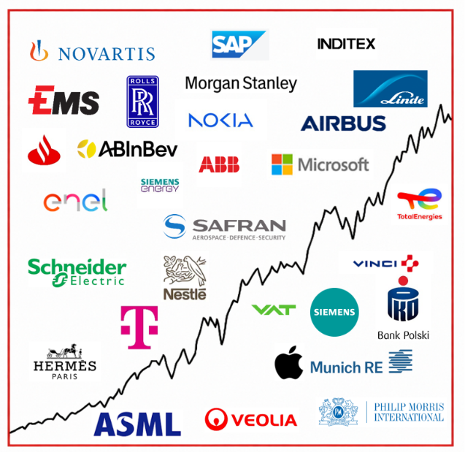  Current Composition (2026)  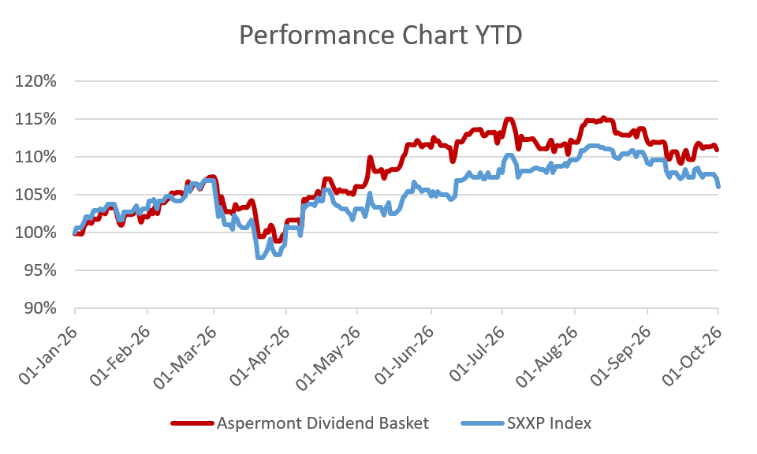  Performance 12m: Source Bloomberg

Return
 | Jan | Feb | Mar | Apr | May | Jun | Jul | Aug | Sep | Oct | Nov | Dec | YTD
2013 |  |  |  |  |  | -0.45% | 3.76% | -1.26% | 3.13% | 2.37% | 1.85% | -0.45% | 9.18%
2014 | -2.29% | 3.09% | 0.73% | 1.53% | 2.66% | 0.43% | -1.12% | 1.13% | 0.95% | -0.60% | 6.09% | -2.26% | 10.52%
2015 | 7.71% | 0.77% | 5.42% | 2.75% | -1.34% | -4.10% | 3.76% | -8.30% | -0.70% | 3.59% | 1.96% | -3.47% | 8.19%
2016 | -4.97% | -1.93% | 1.56% | 1.94% | 2.69% | 1.36% | 0.22% | -1.65% | 0.46% | -1.04% | -1.31% | 5.31% | 2.29%
2017 | -0.31% | 2.65% | 2.99% | 0.94% | 1.65% | -2.27% | -1.10% | 0.06% | 1.39% | 2.23% | 0.23% | -0.56% | 8.03%
2018 | 0.53% | -2.94% | -1.78% | 3.40% | -0.54% | -0.22% | 4.12% | 0.10% | 0.30% | -6.18% | -0.31% | -8.12% | -12.91%
2019 | 6.88% | 5.52% | 2.43% | 2.52% | -3.48% | 2.06% | 0.51% | 0.41% | 1.15% | -0.27% | 0.67% | 0.22% | 19.79%
2020 | -0.33% | -8.12% | -10.0% | 4.75% | 3.00% | 4.63% | -1.07% | 5.55% | -1.78% | -6.40% | 13.6% | 0.98% | 2.39%
2021 | 0.91% | 1.54% | 5.44% | 0.54% | 1.97% | 3.16% | 0.00% | 1.81% | -3.01% | 5.86% | -0.54% | +3.16% | 22.54%
2022 | -2.59% | -6.62% | -0.23% | 0.0% | -2.74% | -5.63% | 5.96% | -3.64% | -5.71% | 5.80% | 4.61% | -3.81% | -14.59%
2023 | 3.84% | 1.31% | 1.94% | 3.87% | -2.50% | 1.60% | 1.68% | -1.54% | -3.25% | -0.75% | 3.79% | 1.85% | 12.13%
2024 | 1.32% | 3.15% | 2.13% | -1.23% | 1.38% | 1.58% | -0.45% | 1.04% | -0.53% | -1.08% | 1.22% | -2.01 | 6.58%
2025 | 5.39% | 1.98% | -5.58% | -1.84% | 3.56% | -0.97% | -1.25% | -0.94% | 3.08% | 1.20% | -2.30% | 0.18% | 2.02%%
2026 | 2.24% | 5.09% | -6.86% | 6.11% | 5.20% | 1.42% | -1.11% | 0.55% | -1.46% |  |  |  | 11.01%

Figures & Ratios
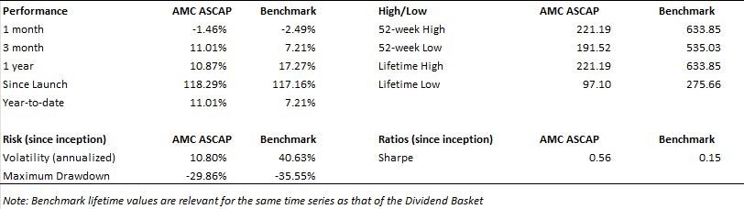
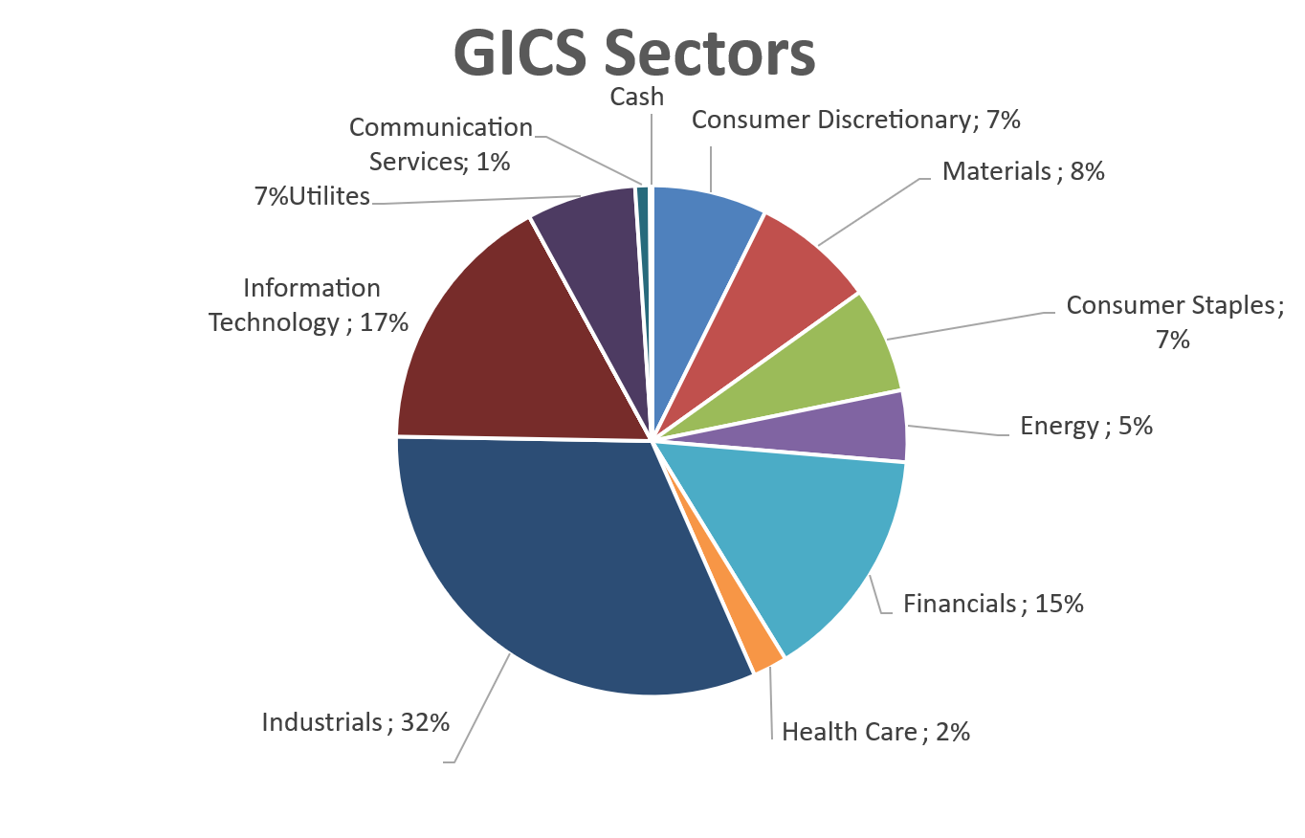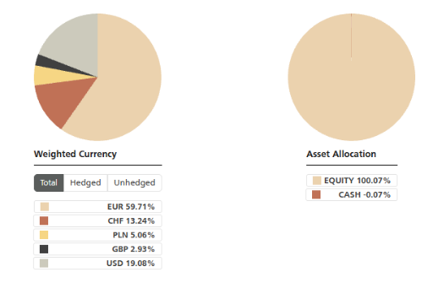

Certificate Terms  Issuer: UBS AG  Advisor: Aspermont Capital AG  ISIN: CH0215884732  Profile: Tracker-Certificate (SVSP-Code: 1300)  Launch date: June 2013 | Currency: EUR  Denomination: EUR 100 per Unit  Maturity: June 12, 2018 (extended to June 13, 2028)  Listing: SIX Swiss Exchange (SIX Structured)

