Market Monthly
September 2026
Highlights
- Economics Global equities ended on a negative note in September. In the US, the advanced reading of the annualized GDP for 2Q26 came in higher than expected and previous (1.5%) at 2.2%. The unemployment rate for August came in at 4.1%, the same as previous and expected. Preliminary US Manufacturing PMI for August came in at 57.0, higher than expected (53.4) and higher than previous 53.9. Services final August numbers was 58.7, above the expected, 55.8, and the revised previous 56.5. In Europe the YoY final reading GDP for 2Q26 came in at 1.2%, more than the previous quarter (1.0%). Eurozone aggregate unemployment for July was 6.4%. PMI numbers for final August were as follows: manufacturing 52.7 below previous and expected 52.8; services, 51.6 below previous 51.7 and expected 51.7.
- Inflation: July CPI in USA was 3.4%, the same as previous, and the same as expected; the preferable FED measure, core price inflation (PCE) YoY was now published for August at 3.4%, lower than previous and expected (3.7%). Eurozone inflation for August was published and came in at 3.2%, the same as expected and higher than previous 2.9%. Inflation figures in other economies were as follows: China 0.8%, India 4.82%, Brazil 4.47%, Russia 6.33%
- Central bank interest rates: In the sixth FED meeting of 2026, the rates were raised by 25 bps with the upper bound rate at 4.00%. The next meeting is scheduled for October 28, 2026. As for the ECB, their sixth meeting of 2026 took place September 10, 2026 where they raised rates by 25bps to the current main refinancing rate of 2.65%, the next meeting is October 29th, 2026.
- Capital market rates: During the month of September, the yield on the 10Y Treasuries moved up to 5.29% from 4.75% and the general USD yield curve shifted up on 1 – 10 year maturities. In the 10Y Bund, the general curve moved up with 10yr maturity at 3.58% from 3.32% and up with the rest of the maturities.
Tactical Asset Allocation
- Forex: The USD weakened against the EUR after being strong in August and at the end of the month noted at 0.88 EUR/USD down -2.39%.
- Bonds incl. High Yields (N): US Treasury yields initially peaked in January 2025, with increased inflation, mainly due to higher energy prices, the FED has moved to increasing rates to curb inflation. The ongoing crisis continues to drive up the cost of goods globally and with that we anticipate inflation remain elevated. With central banks increasing rates, we see new opportunities for expiring bonds in the near future.
- Equities (O): September was a negative month for the individual markets, with the US markets S&P500 down
-0,45%; Dax down -4.03%; Eurostoxx 50 down -2.35% and the SMI down -3.19%.
- Commodities (O): Crude oil had a good month in September going from$85.76/barrel to $90.42/barrel (+5.43%), with the various conflicts still ongoing. Gold ended on a negative note in September ending at $4’157.56/oz (-6.22%).
Investment Ideas
- Due to the ongoing conflict we continue to observe the situation in the middle east and remain cautious. AI still dominates the headlines and pushes tech stocks to new highs for companies supplying the boom and punishes others for overspending on it.
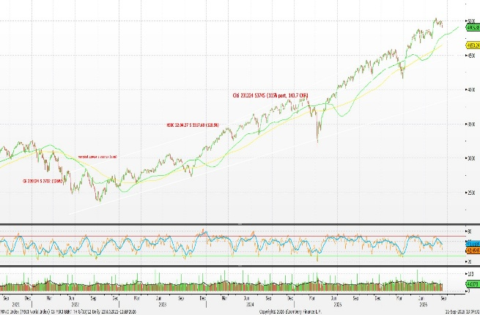
Performance Equity Markets MSCI World 5Y

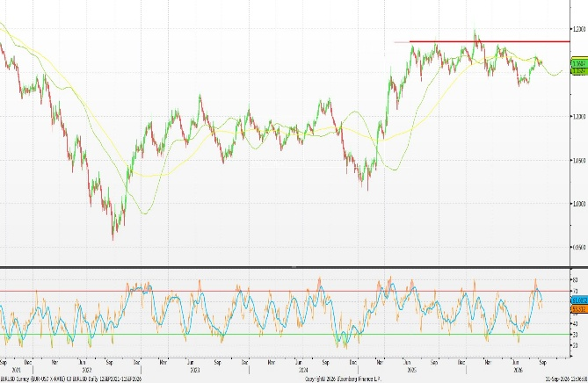

EURUSD Technical Chart 5y, Bloomberg

How to read: (U) underweight; (N) neutral; (O) overweight

