AMC Aspermont Dividend Stock Basket
Product update as of August 31, 2026
NAV per share (August 31, 2026): EUR 221.97, monthly performance: 0.55%, YTD:12.65%, since inception: +121.53%

The Aspermont Dividend Stock Basket
The Actively Managed (Strategy) Certificate (AMC) linked to the Aspermont Capital Dividend Stock Basket provides investors access to a broadly diversified portfolio of around 30 attractive value stocks. We particularly seek out companies with stable or growing dividends and payout ratios, driven by healthy balance sheet structures and sustainable revenue and earnings growth. While screening for such quantitative elements as margin growth, free cash flow and debt-to-equity ratios, qualitative aspects like management performance and corporate strategy are also included in our selection process. A minimum of 80% of the portfolio will be invested in large cap names with market capitalizations of over EUR 10 billion.
Manager’s Comment
In August, the Dividend Basket delivered a performance of 0.55%. The conflict is still ongoing and the and the major markets had mixed performance: DAX +2.45%, Eurostoxx 50 +0.98%, SMI -0.42%, S&P500 +2.62%. In general, we continued with the lower overall USD exposure of around 18%. The USD has been weak in the past months and in August it weakened against the EUR with -0.87%.  The biggest contributor in our portfolio this month was SAP that performed +21%, contributing 0.5% to the portfolio’s performance. This performance was mainly on a strong rebound after July weakness. Robust Q2 results—cloud backlog +26% at constant currencies and cloud revenue +24%—restored confidence in the cloud transition. Growing enthusiasm around SAP’s Business AI strategy and industry-specific AI products also supported valuation recovery.  Five of our top weights (Banco Santander, Inditex, Apple, Linde and Siemens)  outperformed the market (0.29%) in August while two of our top weights underperformed the market. Safran (-0.505 performance) underperformed in August, despite excellent H1 results. After initially rallying above €360, the shares reversed as investors took profits following a strong YTD run. Valuation concerns increased citing caution over 2027 civil-engine aftermarket momentum. TotalEnergies (-1.25% performance) was relatively weak in August after a very strong first half. Despite solid Q2 cash flow and a higher dividend, investors focused on Middle East production disruptions, affecting up to ~10% of output, and softer late-August oil-price sentiment. Profit-taking after a roughly 40% YTD rally also limited upside. Lastly, our weakest stock was Anheuser-Busch InBev (-9.3% performance) that underperformed in August, despite strong Q2 results. Revenue rose 5.6%, beer volumes +1.1% and underlying EPS +23.4%, but the stock had reached a 52-week high on July 31. August therefore saw profit-taking and valuation normalization, compounded by lingering concerns over softer consumer demand in some markets.  The EUR cash position ended the month at approximately 4.9%. Nokia also rebounded +17.5%, contributing 0.38% to the portfolio as investors increasingly rewarded its exposure to AI and cloud infrastructure. Q2 sales rose 9% at constant currencies, with AI & Cloud customer sales +105%, Optical Networks +20% and IP Networks +16%. August’s NVIDIA-backed Zankore AI infrastructure partnership further strengthened the AI investment case. Microsoft (8% perf, 0.25% contribution) Microsoft outperformed in August following very strong FY26 Q4 results. Azure revenue grew 43%, Microsoft Cloud +27%, while commercial backlog surged 84% to $678bn. Management also guided Azure growth to ~45% for the next quarter. Strong AI demand, capacity expansion and accelerating cloud growth reinforced confidence in Microsoft’s AI leadership. |  | 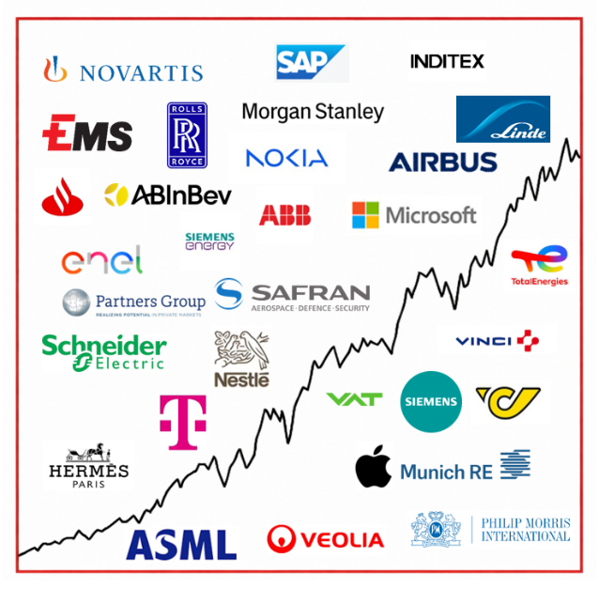  Current Composition (2026)  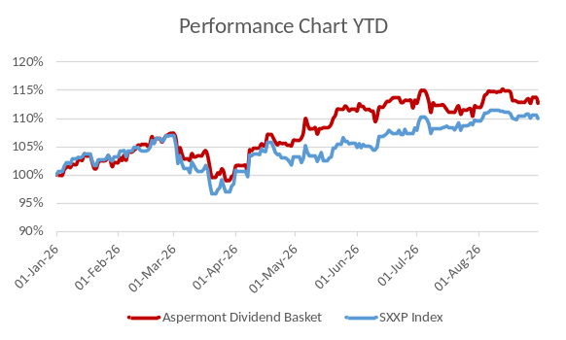  Performance 12m: Source Bloomberg

Return
 | Jan | Feb | Mar | Apr | May | Jun | Jul | Aug | Sep | Oct | Nov | Dec | YTD
2013 |  |  |  |  |  | -0.45% | 3.76% | -1.26% | 3.13% | 2.37% | 1.85% | -0.45% | 9.18%
2014 | -2.29% | 3.09% | 0.73% | 1.53% | 2.66% | 0.43% | -1.12% | 1.13% | 0.95% | -0.60% | 6.09% | -2.26% | 10.52%
2015 | 7.71% | 0.77% | 5.42% | 2.75% | -1.34% | -4.10% | 3.76% | -8.30% | -0.70% | 3.59% | 1.96% | -3.47% | 8.19%
2016 | -4.97% | -1.93% | 1.56% | 1.94% | 2.69% | 1.36% | 0.22% | -1.65% | 0.46% | -1.04% | -1.31% | 5.31% | 2.29%
2017 | -0.31% | 2.65% | 2.99% | 0.94% | 1.65% | -2.27% | -1.10% | 0.06% | 1.39% | 2.23% | 0.23% | -0.56% | 8.03%
2018 | 0.53% | -2.94% | -1.78% | 3.40% | -0.54% | -0.22% | 4.12% | 0.10% | 0.30% | -6.18% | -0.31% | -8.12% | -12.91%
2019 | 6.88% | 5.52% | 2.43% | 2.52% | -3.48% | 2.06% | 0.51% | 0.41% | 1.15% | -0.27% | 0.67% | 0.22% | 19.79%
2020 | -0.33% | -8.12% | -10.0% | 4.75% | 3.00% | 4.63% | -1.07% | 5.55% | -1.78% | -6.40% | 13.6% | 0.98% | 2.39%
2021 | 0.91% | 1.54% | 5.44% | 0.54% | 1.97% | 3.16% | 0.00% | 1.81% | -3.01% | 5.86% | -0.54% | +3.16% | 22.54%
2022 | -2.59% | -6.62% | -0.23% | 0.0% | -2.74% | -5.63% | 5.96% | -3.64% | -5.71% | 5.80% | 4.61% | -3.81% | -14.59%
2023 | 3.84% | 1.31% | 1.94% | 3.87% | -2.50% | 1.60% | 1.68% | -1.54% | -3.25% | -0.75% | 3.79% | 1.85% | 12.13%
2024 | 1.32% | 3.15% | 2.13% | -1.23% | 1.38% | 1.58% | -0.45% | 1.04% | -0.53% | -1.08% | 1.22% | -2.01 | 6.58%
2025 | 5.39% | 1.98% | -5.58% | -1.84% | 3.56% | -0.97% | -1.25% | -0.94% | 3.08% | 1.20% | -2.30% | 0.18% | 2.02%%
2026 | 2.24% | 5.09% | -6.86% | 6.11% | 5.20% | 1.42% | -1.11% | 0.55% |  |  |  |  | 12.65%

Figures & Ratios
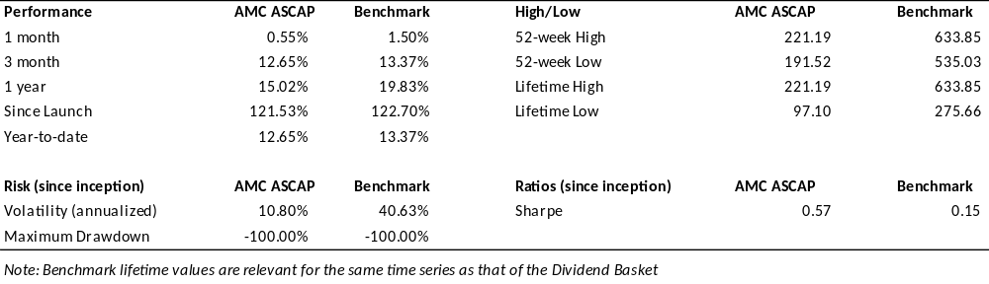
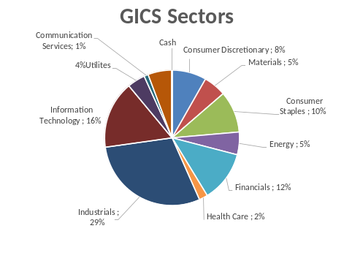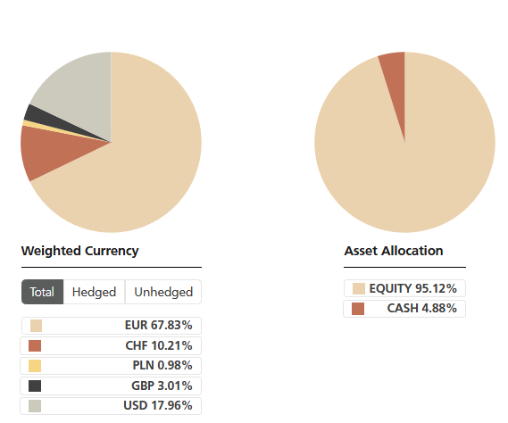

Certificate Terms  Issuer: UBS AG  Advisor: Aspermont Capital AG  ISIN: CH0215884732  Profile: Tracker-Certificate (SVSP-Code: 1300)  Launch date: June 2013 | Currency: EUR  Denomination: EUR 100 per Unit  Maturity: June 12, 2018 (extended to June 13, 2028)  Listing: SIX Swiss Exchange (SIX Structured)

