Market Monthly
August 2026
Highlights
- Economics Global equities ended on a positive note in August. In the US, the advanced reading of the annualized GDP for 2Q26 came in the same as expected and previous at 1.5%. The unemployment rate for August came in at 4.1%, the same as previos and expected. Final US Manufacturing PMI for August came in at 53.9, higher than expected (53.4) and higher than revised previous 53.2. Services final August numbers was 56.5, under the expected, 56.8, and the revised previous. In Europe the YoY advanced reading GDP for 2Q26 came in at 1.2%, more than the previous quarter, 1.0%. Eurozone aggregate unemployment for July was 6.4%. PMI numbers for final August were as follows: manufacturing 52.7 below previous and expected 52.8; services, 51.6 slightly below previous 51.7 and expected 51.7.
- Inflation: July CPI in USA was 3.4%, lower than previous, and the same as expected; the preferable FED measure, core price inflation (PCE) YoY was now published for July at 3.7%, same as previous and higher than expected (3.6%). Eurozone inflation for August was published 19.08.26 and came in at 2.9%, same as expected and previous. Inflation figures in other economies were as follows: China 0.5%, India 4.45%, Brazil 4.24%, Russia 5.98%
- Central bank interest rates: In the fifth FED meeting of 2026, the rates were left at their current level with the upper bound rate at 3.75%. The next meeting is scheduled for September 16, 2026. As for the ECB, their fifth meeting of 2026 took place August 23, 2026 and the current main refinancing rate is at 2.45%, the next meeting is September 10th, 2026.
- Capital market rates: During the month of August, the yield on the 10Y Treasuries moved up to 4.75% from 4.74% and the general USD yield curve shifted up on 1 – 10 year maturities. In the 10Y Bund, the general curve moved up with 10yr maturity at 3.32% from 3.21% and up with the rest of the maturities.
Tactical Asset Allocation
- Forex: The USD weakened against the EUR after being strong in July and at the end of the month noted at 0.86 EUR/USD down -0.86%.
- Bonds incl. High Yields (N): Our view that US Treasury yields peaked in January 2025 remains intact. The ongoing crisis continues to drive up the cost of goods globally and with that we anticipate inflation to move higher. Against this backdrop, we do not expect the central bank to cut interest rates in the near term.
- Equities (O): August was a mixed month for the individual markets, with the US markets S&P500 down
-0.13%; Dax up +2.45%; Eurostoxx 50 up +0.98% and the SMI up -0.42%.
- Commodities (O): Crude oil had a good month in August going from $84.67/barrel to $85.76/barrel (+1.29%), with the various conflicts still ongoing. Gold ended on a positive note in April ending at $4’433.37/oz (+9.64%%).
Investment Ideas
- Due to the ongoing conflict we continue to observe the situation in the middle east and remain cautious. AI still dominates the headlines and pushes tech stocks to new highs for companies supplying the boom and punishes others for overspending on it.
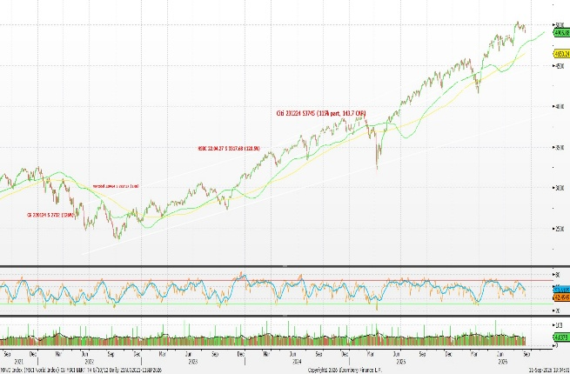
Performance Equity Markets MSCI World 5Y

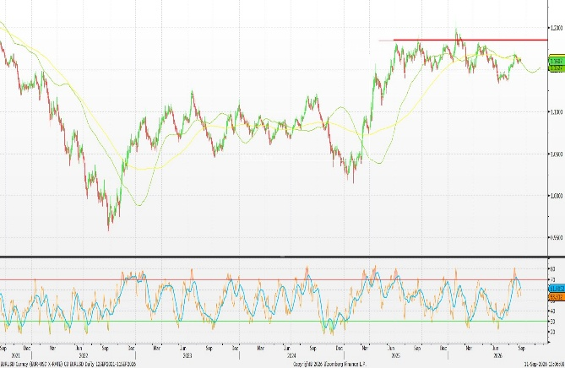

EURUSD Technical Chart 5y, Bloomberg

How to read: (U) underweight; (N) neutral; (O) overweight

