AMC Aspermont European Equity Rotator Basket
Product update as August 31, 2026
Certificate price (August 31, 2026): EUR 167.69 monthly performance: 0.77%, YTD: 9.41%, since inception: +99.57%

The Aspermont European Equity Rotator Basket
The Actively Managed Certificate (AMC) linked to the Aspermont European Equity Rotator Basket gives investors the opportunity to invest in a dynamic, broadly diversified European equity portfolio. Since investments are made exclusively in indices, stock-specific risks are eliminated. The strategy is designed to give the manager the opportunity to add direct sector exposure by under/overweighting specific segment compared to index weight. Target weightings are determined by both fundamental and technical aspects and are continuously reviewed and adjusted as necessary. We place emphasis on the relative strength indicator (RSI), which is a technical momentum indicator that compares the magnitude of recent gains to recent losses of the asset to identify overbought and oversold conditions.

Manager’s Comment
European stock markets had a positive month as hope remains for a possible end to the conflict; the broader STOXX Europe 600 Index grew +0.29%. The Aspermont European Rotator Basket during August outperformed the Stoxx 600 with a return of +0.77%. At the end of the month, the basket was invested across 19 European sectors, holding a cash position of 0.0%.  Our +2.5% Overweight position in Information Technology was the biggest contributor this month (3.7% perf, 0.37% contribution), after initially rallying, the sector then came under pressure as global semiconductors were in a sell-off and Infineon came under pressure whilst SAP and ASML finished the month on a positive note. We reduced the sector Aug 24th to Neutral and locked in some of the positive performance. Our 2.5% Overweight in Banks also paid off, as the sector outperformed the index (+1.97% perf), contributing 0.30% to the performance of the portfolio. The banking sector was driven by interest-rate expectations that would be supportive for bank profitability as it protects their net interest margins. Additionally, the sector also profited from the strong Q2 earnings season with banks reporting late July and early August that demonstrated strong earnings. Our new underweight position in August was Personal & Household Goods that we changed to -2.5% Underweight towards the end of the month as Chinese consumer spending remained weak, putting companies such as LVMH and Dior under pressure as they are considered more aspirational luxury brands. Hermes performed considerably better, showing again that ultra high end customers are no affected  Health Care (+2.61%) contributed +0.32%, while the sector was increased from Neutral to +1% Overweight towards the end of the month as we saw increasing rotation into defensive stocks. The best-performing sector was Financial Services (+5.59%, Neutral), contributing +0.23%.  Portfolio activity during the month focused on reducing cyclical and technology risk while increasing defensive exposure. |  | 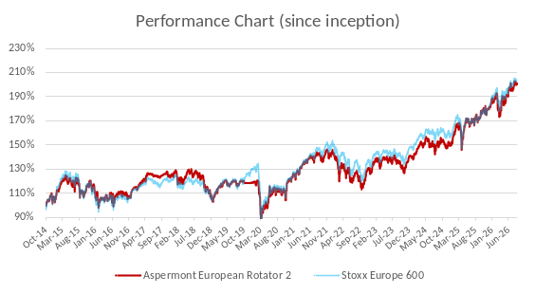  Performance since launch vs. STOXX Europe 600 (rebased)  Source: Bloomberg  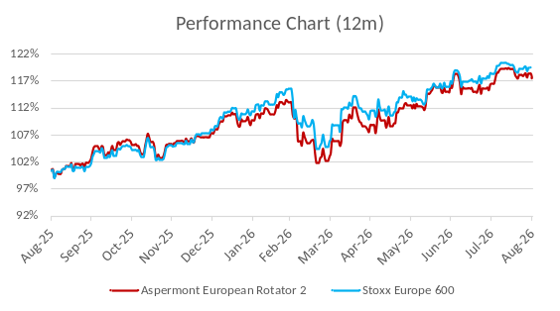  AMC 12m performance vs. STOXX Europe 600 (rebased)  Source: Bloomberg

Returns
 | Jan | Feb | Mar | Apr | May | Jun | Jul | Aug | Sep | Oct | Nov | Dec | YTD
2014 |  |  |  |  |  |  |  |  |  | 4.62% | 3.56% | -2.36% | 5.79%
2015 | 5.76% | 5.48% | 2.51% | -1.43% | 0.81% | -4.62% | 4.32% | -6.23% | -3.23% | 6.70% | 3.93% | -3.49% | 9.85%
2016 | -4.37% | -5.35% | 0.26% | 0.54% | 3.75% | -5.06% | 4.45% | 0.02% | 0.66% | -1.58% | -0.63 | 5.57% | -2.00%
2017 | -1.25% | 3.77% | 4.26% | 1.98% | 1.27% | -1.45% | -0.04% | -0.27% | 1.62% | 1.62% | -2.31% | -0.65% | 8.40%
2018 | 2.61% | -3.34% | -2.36% | 4.38% | 0.90% | -1.26% | 2.68% | -1.91% | -1.10% | -7.80% | -2.50% | -5.64% | -14.90%
2019 | 5.57% | 4.01% | 1.00% | 3.69% | -4.25% | 3.18% | 0.00% | -0.81% | 1.61% | -1.57% | 0.00% | 0.09% | 14.50%
2020 | -1.77% | -6.11% | -11.8% | 5.32% | 4.81% | 3.31% | -1.47% | 3.28% | -1.53% | -5.46% | 15.6% | 2.59% | 4.21%
2021 | -1.88% | 3.40% | 5.93% | 2.31% | 1.94% | 0.90% | 0.55% | 1.71% | -4.15% | 4.10% | -2.30% | 3.81% | 16.63%
2022 | -3.45% | -4.87% | 0.16% | -1.97% | 0.22% | -7.80% | 5.52% | -4.50% | -5.48% | 6.15% | 7.29% | -1.97% | -11.38%
2023 | 6.27% | 1.25% | -0.16% | 1.59% | -2.96% | 3.13% | 1.51% | -3.25% | -3.06% | -3:43% | 7.37% | 3.27% | 10.37%
2024 | 1.22% | 2.76% | 4.22% | -1.58% | 2.36% | -3.61% | 1.47% | 1.52% | 0.99% | -3.31% | -0.22% | 1.02% | 6.74%
2025 | 6.91% | 3.12% | -3.14% | 1.06% | 4.77% | -1.11% | 1.23% | 0.33% | 2.20% | 2.49% | 0.18% | 1.80% | 21.30%
2026 | 2.24% | 3.09% | -8.35% | 5.06% | 3.30% | 3.50% | 0.05% | 0.77% |  |  |  |  | 9.41%

Figures & Ratios
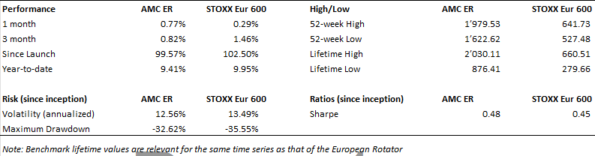
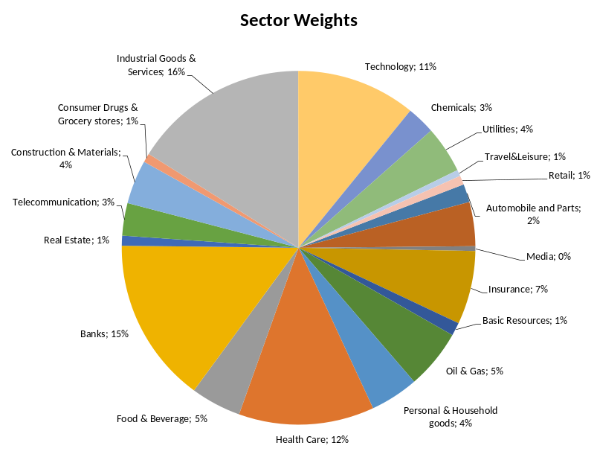
Certificate Terms  Issuer: UBS AG, Zurich  Investment Manager: Aspermont Capital AG  ISIN: CH0473592290  Profile: Tracker-Certificate (SVSP-Code: 1300)  Launch date: December 09, 2019 | ..  Currency: EUR  Denomination: EUR 1000 per Unit  Maturity date: December 09, 2026  Listing: None  (Original launch October 20, 2014)

