AMC Aspermont Dividend Stock Basket
Product update as of July 31, 2026
NAV per share (June 30, 2026): EUR 220.1, monthly performance: -1.11%, YTD:12.03%, since inception: +120.31%

The Aspermont Dividend Stock Basket
The Actively Managed (Strategy) Certificate (AMC) linked to the Aspermont Capital Dividend Stock Basket provides investors access to a broadly diversified portfolio of around 30 attractive value stocks. We particularly seek out companies with stable or growing dividends and payout ratios, driven by healthy balance sheet structures and sustainable revenue and earnings growth. While screening for such quantitative elements as margin growth, free cash flow and debt-to-equity ratios, qualitative aspects like management performance and corporate strategy are also included in our selection process. A minimum of 80% of the portfolio will be invested in large cap names with market capitalizations of over EUR 10 billion.
Manager’s Comment
In July, the Dividend Basket delivered a performance of -1.11%. While there is hope about a possible end to the conflict, the major driver this month was the tech industry. The major markets had mixed performance: DAX +2.53%, Eurostoxx 50 +0.47%, SMI +1.07%, S&P500 -0.13%. In general, we continued with the lower overall USD exposure of around 20%. The USD has been weak in the past months and in July it weakened against the EUR with -0.89%.  Six broadly diversified companies with OW of 5% in the divided basket have outperformed the market. TotalEnergies rose 12.2% and added 0.50%, supported by firm commodity prices and strong quarterly cash generation. Apple with a performance of 7.0% contributed +0.31%. The shares were supported by strong fiscal Q3 results, with revenue rising 16% year-on-year. Anheuser-Busch InBev (perf +3.41%) and Banco Santander (perf +3.32%) contributed +0.18% and +0.17%, respectively. Inditex (perf +3.23%) contributed +0.16%. The shares were supported by a late-July upgrade from Barclays to Overweight, with the broker highlighting Inditex’s pricing power, disciplined inventory management and potential upside to medium-term earnings expectations. Schneider Electric (perf +1.39%) contributed +0.07%. The shares were supported by continued strong data-centre demand and record first-half earnings. Management also upgraded its 2026 financial target.  Microsoft was the strongest performer, rising 23.7%. The 3.1% position added 0.59% after strong cloud and AI results, including further acceleration in Azure. SAP gained 17.6% and contributed 0.36% as second-quarter cloud momentum and backlog growth remained solid. EMS-Chemie increased 16.8% after strong 1H 2026 earnings and an upward revised FY 2026 forecast. Deutsche Telekom also performed well, gaining 12.1%.  While the tech sector continues to be supported by strong demand for AI, chips, datacenters and infrastructure around it there was a broad tech sell-off that affected companies differently. Siemens Energy (-11.1%) was hit by AI valuation revisions; ASML (-17.0%) came under pressure and reports of progress in Chinese lithography equipment; ABB (-10.1%) on M&A concerns as the expensive acquisition overshadowed results; VAT Group (-15.6%) due to capacity-ramp margin pressure; the weakest performer Nokia (-26%) under pressure due to high restructuring costs and doubts about how quickly AI order translate into profit and profit taking after strong AI order intake.  Portfolio activity focused on increasing selected positions following market corrections. Inditex and Banco Santander were raised to approximately 5% after good results, while Ericsson was exited and replaced by Nokia. The EUR cash position approximately 0.1%. |  | 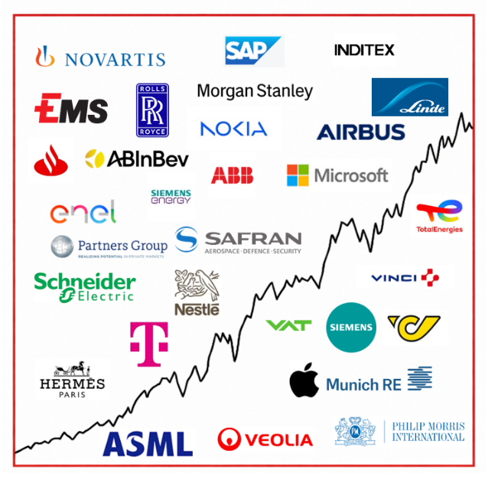  Current Composition (2026)  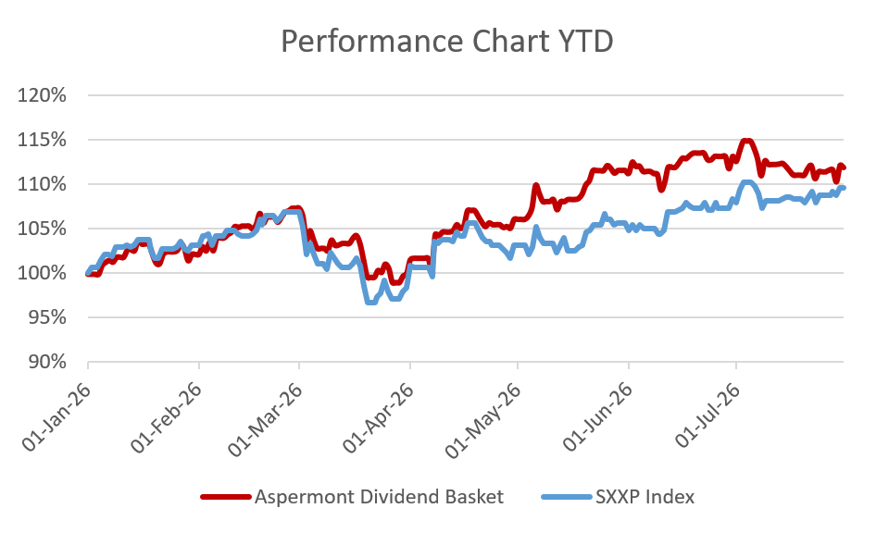  Performance 12m: Source Bloomberg

Return
 | Jan | Feb | Mar | Apr | May | Jun | Jul | Aug | Sep | Oct | Nov | Dec | YTD
2013 |  |  |  |  |  | -0.45% | 3.76% | -1.26% | 3.13% | 2.37% | 1.85% | -0.45% | 9.18%
2014 | -2.29% | 3.09% | 0.73% | 1.53% | 2.66% | 0.43% | -1.12% | 1.13% | 0.95% | -0.60% | 6.09% | -2.26% | 10.52%
2015 | 7.71% | 0.77% | 5.42% | 2.75% | -1.34% | -4.10% | 3.76% | -8.30% | -0.70% | 3.59% | 1.96% | -3.47% | 8.19%
2016 | -4.97% | -1.93% | 1.56% | 1.94% | 2.69% | 1.36% | 0.22% | -1.65% | 0.46% | -1.04% | -1.31% | 5.31% | 2.29%
2017 | -0.31% | 2.65% | 2.99% | 0.94% | 1.65% | -2.27% | -1.10% | 0.06% | 1.39% | 2.23% | 0.23% | -0.56% | 8.03%
2018 | 0.53% | -2.94% | -1.78% | 3.40% | -0.54% | -0.22% | 4.12% | 0.10% | 0.30% | -6.18% | -0.31% | -8.12% | -12.91%
2019 | 6.88% | 5.52% | 2.43% | 2.52% | -3.48% | 2.06% | 0.51% | 0.41% | 1.15% | -0.27% | 0.67% | 0.22% | 19.79%
2020 | -0.33% | -8.12% | -10.0% | 4.75% | 3.00% | 4.63% | -1.07% | 5.55% | -1.78% | -6.40% | 13.6% | 0.98% | 2.39%
2021 | 0.91% | 1.54% | 5.44% | 0.54% | 1.97% | 3.16% | 0.00% | 1.81% | -3.01% | 5.86% | -0.54% | +3.16% | 22.54%
2022 | -2.59% | -6.62% | -0.23% | 0.0% | -2.74% | -5.63% | 5.96% | -3.64% | -5.71% | 5.80% | 4.61% | -3.81% | -14.59%
2023 | 3.84% | 1.31% | 1.94% | 3.87% | -2.50% | 1.60% | 1.68% | -1.54% | -3.25% | -0.75% | 3.79% | 1.85% | 12.13%
2024 | 1.32% | 3.15% | 2.13% | -1.23% | 1.38% | 1.58% | -0.45% | 1.04% | -0.53% | -1.08% | 1.22% | -2.01 | 6.58%
2025 | 5.39% | 1.98% | -5.58% | -1.84% | 3.56% | -0.97% | -1.25% | -0.94% | 3.08% | 1.20% | -2.30% | 0.18% | 2.02%%
2026 | 2.24% | 5.09% | -6.86% | 6.11% | 5.20% | 1.42% | -1.11% |  |  |  |  |  | 12.03%

Figures & Ratios
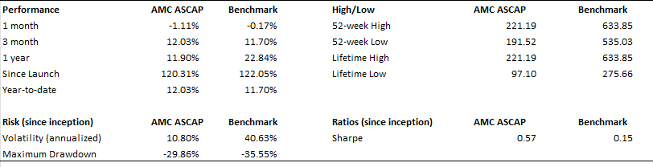
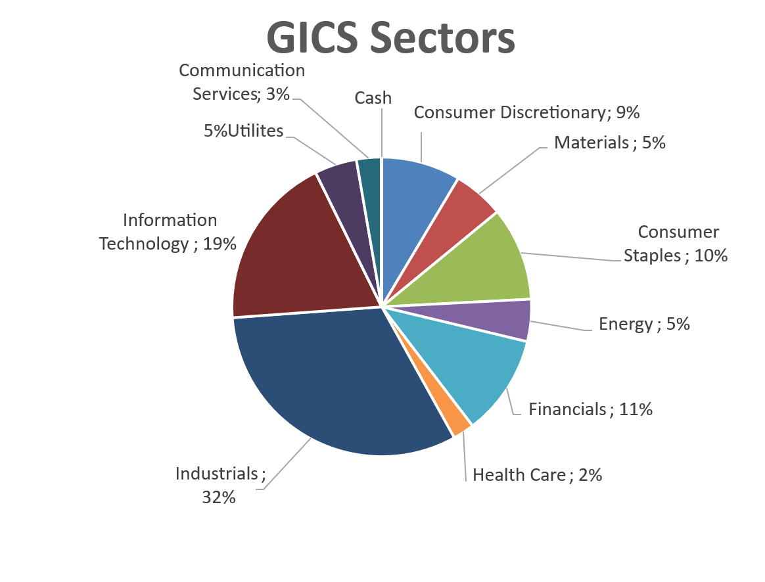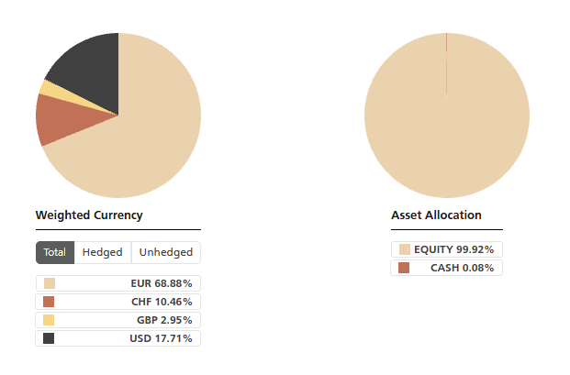

Certificate Terms  Issuer: UBS AG  Advisor: Aspermont Capital AG  ISIN: CH0215884732  Profile: Tracker-Certificate (SVSP-Code: 1300)  Launch date: June 2013 | Currency: EUR  Denomination: EUR 100 per Unit  Maturity: June 12, 2018 (extended to June 13, 2028)  Listing: SIX Swiss Exchange (SIX Structured)

