AMC Aspermont European Equity Rotator Basket
Product update as July 31, 2026
Certificate price (May 31, 2026): EUR 160.70 monthly performance: 0.50%, YTD: 8.57%, since inception: +98.05%

The Aspermont European Equity Rotator Basket
The Actively Managed Certificate (AMC) linked to the Aspermont European Equity Rotator Basket gives investors the opportunity to invest in a dynamic, broadly diversified European equity portfolio. Since investments are made exclusively in indices, stock-specific risks are eliminated. The strategy is designed to give the manager the opportunity to add direct sector exposure by under/overweighting specific segment compared to index weight. Target weightings are determined by both fundamental and technical aspects and are continuously reviewed and adjusted as necessary. We place emphasis on the relative strength indicator (RSI), which is a technical momentum indicator that compares the magnitude of recent gains to recent losses of the asset to identify overbought and oversold conditions.

Manager’s Comment
European stock markets had a positive month as hope remains for a possible end to the conflict; the broader STOXX Europe 600 Index grew +1.61%. The Aspermont European Rotator Basket during July underperformed the Stoxx 600 with a return of +0.50%. At the end of the month, the basket was invested across 19 European sectors, holding a cash position of 0.01%.  The +2.5% Overweight position in Banks (performance +5.46%) was the strongest contributor, adding +0.76%. The sector was supported by resilient second-quarter earnings expectations, stronger lending and capital-markets revenues, and a higher-rate environment that remained supportive for margins. Banco Santander’s Q2 earnings release was up 15% YoY supported by strong customer activity, higher revenues and continued cost efficiencies.  The best performing sector was Basic Resources (+9.91%), held at a Neutral weight, contributing +0.10%. Mining and metals shares benefited from stronger commodity prices, a weaker US dollar and renewed hopes for measures to support Chinese industrial demand.  Financial Services, a neutral position in our portfolio, performed 5.33% with Deutsche Boerse and Euronext being the strongest performers in the index, making up 50% of the index.  The -2.5% underweight in Telecommunications limited the impact of the sector's -5.26% decline to -0.16%. as Nokia’s was under pressure due to high restructuring costs and doubts about how quickly AI order translate into profit and profit taking after strong AI order intake. This impacted the whole sector.  Technology (+2.5% OW) was the weakest sector in July (-12.86%) as European semiconductor shares were affected by a broader rotation out of high-momentum technology stocks, renewed valuation concerns and pressure on ASML following reports of progress in Chinese lithography equipment.  The largest sector, Industrial Goods & Services (+1.23%, Neutral), contributed +0.20% where Airbus jumped after they unveiled a EUR 5bn share buyback program and the momentum was reinforced with solid H1 results at the end of the month. |  | 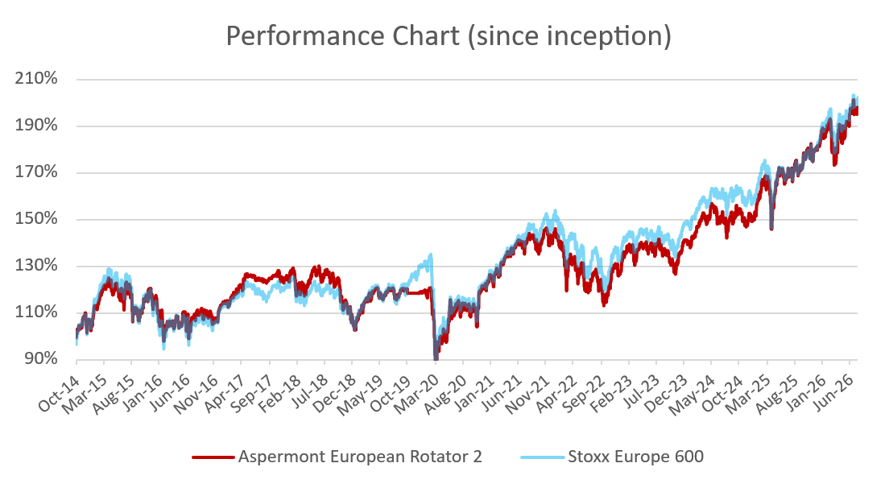  Performance since launch vs. STOXX Europe 600 (rebased)  Source: Bloomberg  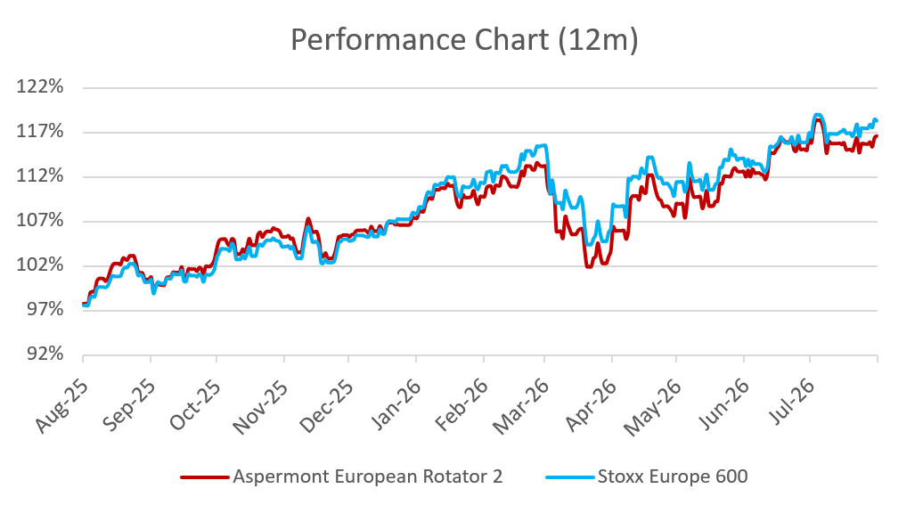  AMC 12m performance vs. STOXX Europe 600 (rebased)  Source: Bloomberg

Returns
 | Jan | Feb | Mar | Apr | May | Jun | Jul | Aug | Sep | Oct | Nov | Dec | YTD
2014 |  |  |  |  |  |  |  |  |  | 4.62% | 3.56% | -2.36% | 5.79%
2015 | 5.76% | 5.48% | 2.51% | -1.43% | 0.81% | -4.62% | 4.32% | -6.23% | -3.23% | 6.70% | 3.93% | -3.49% | 9.85%
2016 | -4.37% | -5.35% | 0.26% | 0.54% | 3.75% | -5.06% | 4.45% | 0.02% | 0.66% | -1.58% | -0.63 | 5.57% | -2.00%
2017 | -1.25% | 3.77% | 4.26% | 1.98% | 1.27% | -1.45% | -0.04% | -0.27% | 1.62% | 1.62% | -2.31% | -0.65% | 8.40%
2018 | 2.61% | -3.34% | -2.36% | 4.38% | 0.90% | -1.26% | 2.68% | -1.91% | -1.10% | -7.80% | -2.50% | -5.64% | -14.90%
2019 | 5.57% | 4.01% | 1.00% | 3.69% | -4.25% | 3.18% | 0.00% | -0.81% | 1.61% | -1.57% | 0.00% | 0.09% | 14.50%
2020 | -1.77% | -6.11% | -11.8% | 5.32% | 4.81% | 3.31% | -1.47% | 3.28% | -1.53% | -5.46% | 15.6% | 2.59% | 4.21%
2021 | -1.88% | 3.40% | 5.93% | 2.31% | 1.94% | 0.90% | 0.55% | 1.71% | -4.15% | 4.10% | -2.30% | 3.81% | 16.63%
2022 | -3.45% | -4.87% | 0.16% | -1.97% | 0.22% | -7.80% | 5.52% | -4.50% | -5.48% | 6.15% | 7.29% | -1.97% | -11.38%
2023 | 6.27% | 1.25% | -0.16% | 1.59% | -2.96% | 3.13% | 1.51% | -3.25% | -3.06% | -3:43% | 7.37% | 3.27% | 10.37%
2024 | 1.22% | 2.76% | 4.22% | -1.58% | 2.36% | -3.61% | 1.47% | 1.52% | 0.99% | -3.31% | -0.22% | 1.02% | 6.74%
2025 | 6.91% | 3.12% | -3.14% | 1.06% | 4.77% | -1.11% | 1.23% | 0.33% | 2.20% | 2.49% | 0.18% | 1.80% | 21.30%
2026 | 2.24% | 3.09% | -8.35% | 5.06% | 3.30% | 3.50% | 0.05% |  |  |  |  |  | 8.57%

Figures & Ratios
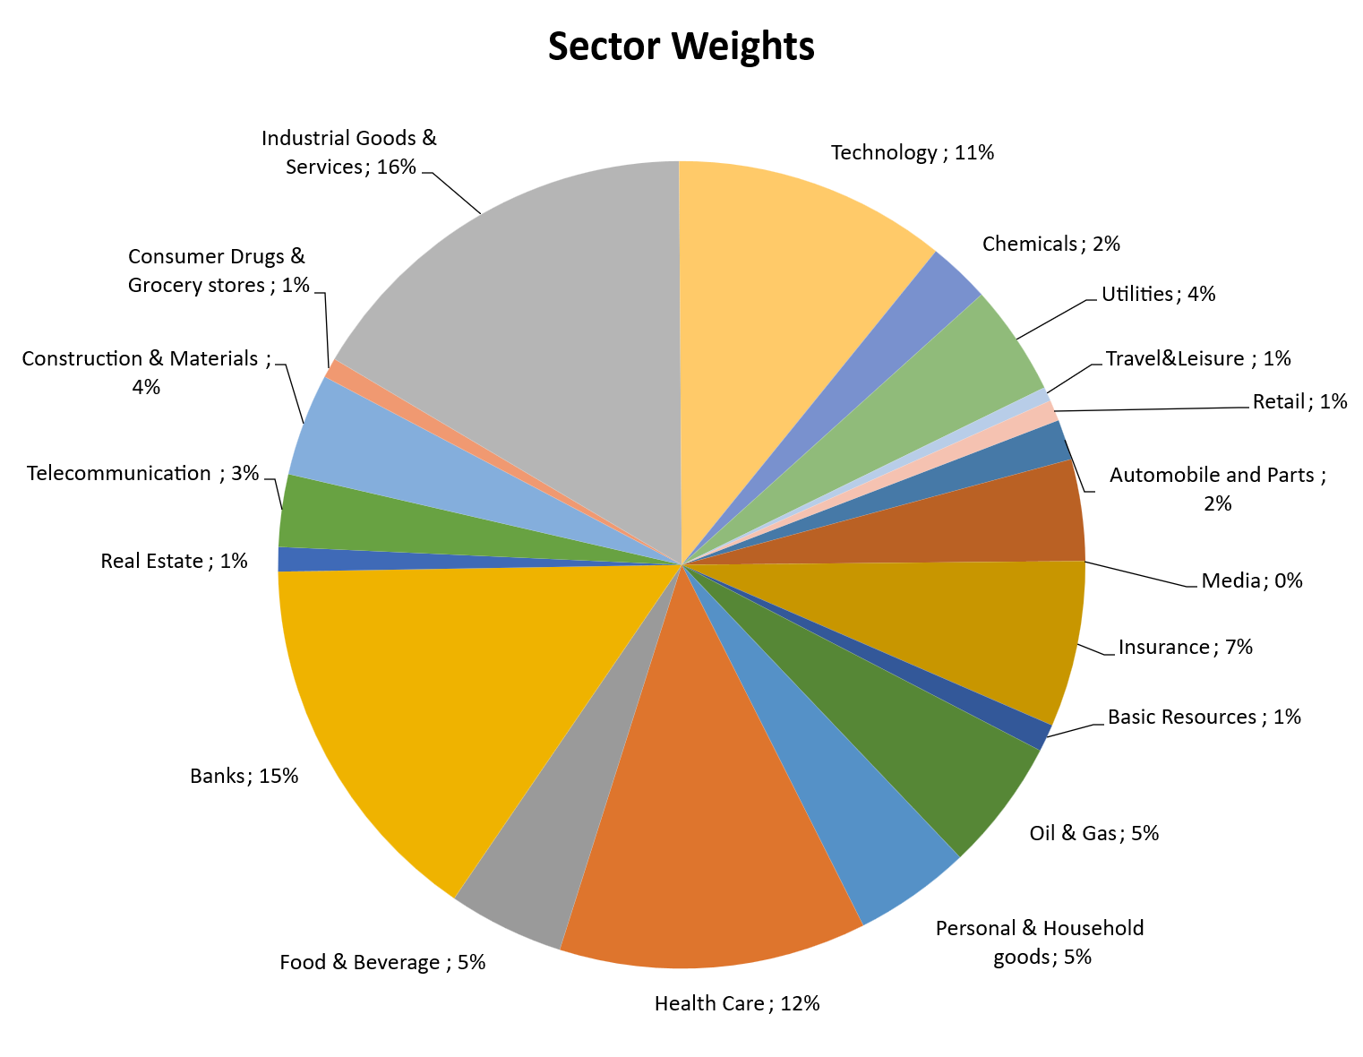
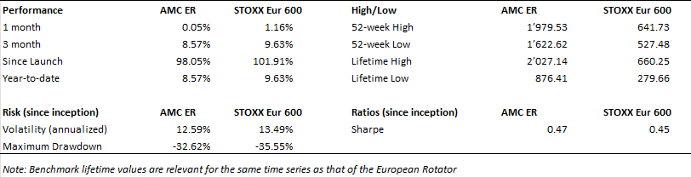
Certificate Terms  Issuer: UBS AG, Zurich  Investment Manager: Aspermont Capital AG  ISIN: CH0473592290  Profile: Tracker-Certificate (SVSP-Code: 1300)  Launch date: December 09, 2019 | ..  Currency: EUR  Denomination: EUR 1000 per Unit  Maturity date: December 09, 2026  Listing: None  (Original launch October 20, 2014)

