AMC Aspermont Dividend Stock Basket
Product update as of May 31, 2026
NAV per share (May 31, 2026): EUR 220.1, monthly performance: +5.20%, YTD:11.70%, since inception: +119.66%

The Aspermont Dividend Stock Basket
The Actively Managed (Strategy) Certificate (AMC) linked to the Aspermont Capital Dividend Stock Basket provides investors access to a broadly diversified portfolio of around 30 attractive value stocks. We particularly seek out companies with stable or growing dividends and payout ratios, driven by healthy balance sheet structures and sustainable revenue and earnings growth. While screening for such quantitative elements as margin growth, free cash flow and debt-to-equity ratios, qualitative aspects like management performance and corporate strategy are also included in our selection process. A minimum of 80% of the portfolio will be invested in large cap names with market capitalizations of over EUR 10 billion.
Manager’s Comment
In May, the Dividend Basket delivered a performance of +5.20%. While there is hope about a possible end to the conflict, the major driver this month was the tech industry. The major markets also recorded positive months: DAX +3.34%, Eurostoxx 50 +2.87%, SMI +3.09%, S&P500 +5.15%  In general, we continued with the lower overall USD exposure of around 20%. The USD has been weak in the past months and in May it strengthened slightly against the EUR with +0.46%.  In May, the same stock that stood out in April was the best performer in our basket – Nokia, a 5% position – was up 35.2% in our basket and we took profit on the stock once at the beginning of the month and once at the end. They outperformed as they launched agentic AI broadband tools and an AI Networking Innovation lab. This reinforced the investor enthusiasm around optical networks, AI Infrastructure demand. ASML, also a 5% position, was the second best performing stock, performing 21.1% in May. They profited from a broad momentum increase in the semiconductor space with AI chip shortages reinforcing the demand for their EUV lithography systems. Apple, a 5% US position performed 16.2% in EUR terms driven by a blowout +2 earnings report with iPhone sales up 22% YoY and the announcement of a $100 billion share buyback program. Our US bank position, Morgan Stanley, also outperformed (+13.5%) with its 2.5% weight in the portfolio. There were analyst upgrades to the bank as their involvement in the SpaceX IPO will generate considerable revenue for them. Munich Re was the weakest performer -17.8% in the basket and although they released strong Q1 earnings and their Dividend payment was at the beginning of May, their April renewals showed a risk adjusted price decline of about 3.1% after years of price increases.  In May we added three Swiss companies, ABB that raised its 2026 growth and margin expectations on strong electrification and automation demand; VAT Group that saw a 47% surge in semiconductor equipment orders driven by AI; and EMS Chemie on resilient specialty polymer demand. In Europe we added Banco Santander that demonstrated strong earnings in retail and commercial banking, and diversified our aerospace exposure by adding Rolls Royce to the mix. |  | 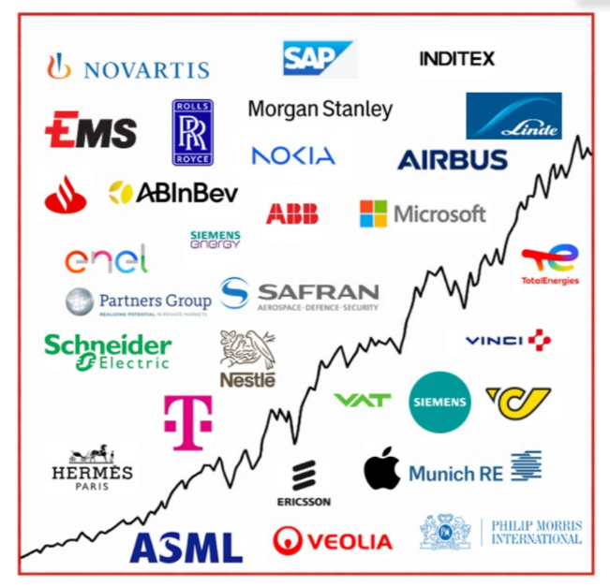  Current Composition (2026)  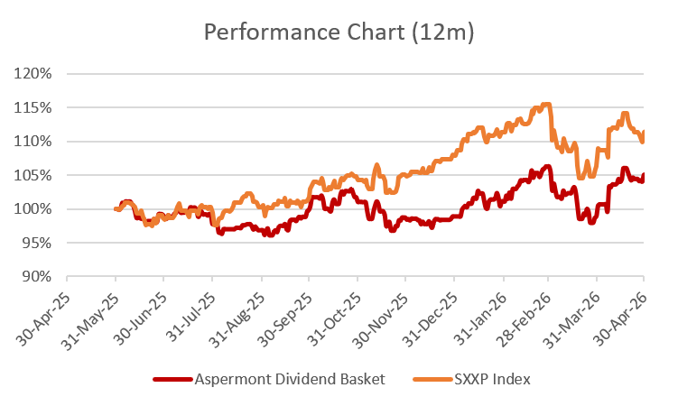  Performance 12m: Source Bloomberg

Return
 | Jan | Feb | Mar | Apr | May | Jun | Jul | Aug | Sep | Oct | Nov | Dec | YTD
2013 |  |  |  |  |  | -0.45% | 3.76% | -1.26% | 3.13% | 2.37% | 1.85% | -0.45% | 9.18%
2014 | -2.29% | 3.09% | 0.73% | 1.53% | 2.66% | 0.43% | -1.12% | 1.13% | 0.95% | -0.60% | 6.09% | -2.26% | 10.52%
2015 | 7.71% | 0.77% | 5.42% | 2.75% | -1.34% | -4.10% | 3.76% | -8.30% | -0.70% | 3.59% | 1.96% | -3.47% | 8.19%
2016 | -4.97% | -1.93% | 1.56% | 1.94% | 2.69% | 1.36% | 0.22% | -1.65% | 0.46% | -1.04% | -1.31% | 5.31% | 2.29%
2017 | -0.31% | 2.65% | 2.99% | 0.94% | 1.65% | -2.27% | -1.10% | 0.06% | 1.39% | 2.23% | 0.23% | -0.56% | 8.03%
2018 | 0.53% | -2.94% | -1.78% | 3.40% | -0.54% | -0.22% | 4.12% | 0.10% | 0.30% | -6.18% | -0.31% | -8.12% | -12.91%
2019 | 6.88% | 5.52% | 2.43% | 2.52% | -3.48% | 2.06% | 0.51% | 0.41% | 1.15% | -0.27% | 0.67% | 0.22% | 19.79%
2020 | -0.33% | -8.12% | -10.0% | 4.75% | 3.00% | 4.63% | -1.07% | 5.55% | -1.78% | -6.40% | 13.6% | 0.98% | 2.39%
2021 | 0.91% | 1.54% | 5.44% | 0.54% | 1.97% | 3.16% | 0.00% | 1.81% | -3.01% | 5.86% | -0.54% | +3.16% | 22.54%
2022 | -2.59% | -6.62% | -0.23% | 0.0% | -2.74% | -5.63% | 5.96% | -3.64% | -5.71% | 5.80% | 4.61% | -3.81% | -14.59%
2023 | 3.84% | 1.31% | 1.94% | 3.87% | -2.50% | 1.60% | 1.68% | -1.54% | -3.25% | -0.75% | 3.79% | 1.85% | 12.13%
2024 | 1.32% | 3.15% | 2.13% | -1.23% | 1.38% | 1.58% | -0.45% | 1.04% | -0.53% | -1.08% | 1.22% | -2.01 | 6.58%
2025 | 5.39% | 1.98% | -5.58% | -1.84% | 3.56% | -0.97% | -1.25% | -0.94% | 3.08% | 1.20% | -2.30% | 0.18% | 2.02%%
2026 | 2.24% | 5.09% | -6.86% | 6.11% | 5.20% |  |  |  |  |  |  |  | 11.70%

Figures & Ratios
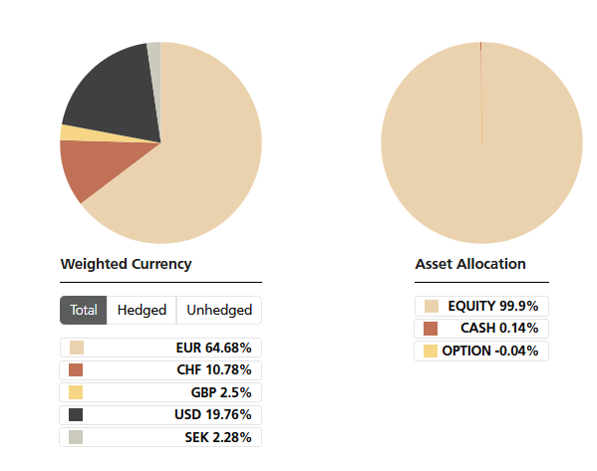
Certificate Terms  Issuer: UBS AG  Advisor: Aspermont Capital AG  ISIN: CH0215884732  Profile: Tracker-Certificate (SVSP-Code: 1300)  Launch date: June 2013 | Currency: EUR  Denomination: EUR 100 per Unit  Maturity: June 12, 2018 (extended to June 13, 2028)  Listing: SIX Swiss Exchange (SIX Structured)

