AMC Aspermont European Equity Rotator Basket
Product update as May 31, 2026
Certificate price (May 31, 2026): EUR 160.70 monthly performance: 3.30%, YTD: 4.85%, since inception: +91.25%

The Aspermont European Equity Rotator Basket
The Actively Managed Certificate (AMC) linked to the Aspermont European Equity Rotator Basket gives investors the opportunity to invest in a dynamic, broadly diversified European equity portfolio. Since investments are made exclusively in indices, stock-specific risks are eliminated. The strategy is designed to give the manager the opportunity to add direct sector exposure by under/overweighting specific segment compared to index weight. Target weightings are determined by both fundamental and technical aspects and are continuously reviewed and adjusted as necessary. We place emphasis on the relative strength indicator (RSI), which is a technical momentum indicator that compares the magnitude of recent gains to recent losses of the asset to identify overbought and oversold conditions.

Manager’s Comment
European stock markets had a positive month as hope remains for a possible end to the conflict; the broader STOXX Europe 600 Index rebounded +2.41%, while the STOXX Europe 50 advanced +2.87%. The Aspermont European Rotator Basket during May outperformed the Stoxx 600 with a return of +3.30%. At the end of the month, the basket was invested across 19 European sectors and zero country indices, holding a cash position of 0.57%.  In May, the best performing sector, for two months in a row was Technology (+13.4%), a sector that we hold in a Neutral position. The sector outperformed in May as ASML led semiconductor gains, AI infrastructure demand strengthened once again and global chip/tech momentum boosted risk appetite with investors. The second-best performing sector was a small sector, Travel and Leisure (+10.02%), a Neutral position, outperforming the market as the oil price retracted, this supported airlines while at the same time summer booking demand stayed resilient. Basic Resources (+9.2%, Neutral) was helped by European cyclicals benefiting from risk-on sentiment.  Our biggest sector, Industrial Goods & Services (+1.89%, +2.5% OW), in May underperformed driven by fading manufacturing momentum, tariff uncertainty, rising input costs, supply-chain concerns and stock-specific pressure from Airbus delivery-delay headlines as one of the biggest companies in the sector. Health Care (+2.59%, -2.5% UW) was positioned well as it underperformed the Stoxx 50 in May as investors rotated towards AI/cyclical winners while pharma keeps facing drug-pricing and US policy uncertainty. Adding to the mix, limited earnings catalysts with patent expiries and slow pipelines also weighed on the sector.  Our second +2.5% OW sector was Banks (+3.39%) Banks outperformed in May as resilient Q1 earnings from UniCredit, Santander and Deutsche Bank confirmed strong margins and credit quality. Intesa’s record profit and €9.4bn shareholder-return plan reinforced payout appeal, while consolidation stories, sticky rates and inexpensive valuations kept investors rotating into European financials despite macro uncertainty broadly. |  | 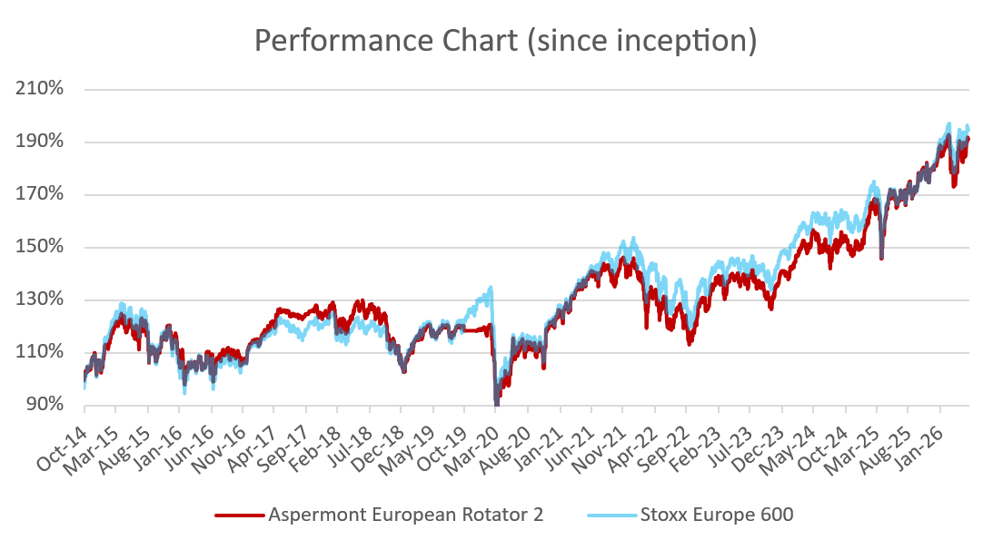  Performance since launch vs. STOXX Europe 600 (rebased)  Source: Bloomberg  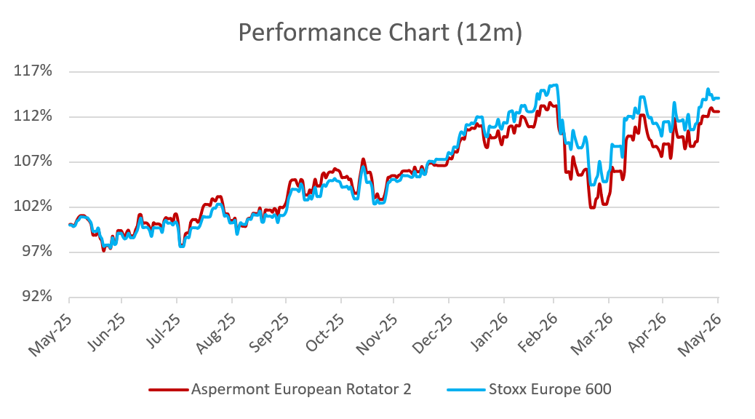  AMC 12m performance vs. STOXX Europe 600 (rebased)  Source: Bloomberg

Returns
 | Jan | Feb | Mar | Apr | May | Jun | Jul | Aug | Sep | Oct | Nov | Dec | YTD
2014 |  |  |  |  |  |  |  |  |  | 4.62% | 3.56% | -2.36% | 5.79%
2015 | 5.76% | 5.48% | 2.51% | -1.43% | 0.81% | -4.62% | 4.32% | -6.23% | -3.23% | 6.70% | 3.93% | -3.49% | 9.85%
2016 | -4.37% | -5.35% | 0.26% | 0.54% | 3.75% | -5.06% | 4.45% | 0.02% | 0.66% | -1.58% | -0.63 | 5.57% | -2.00%
2017 | -1.25% | 3.77% | 4.26% | 1.98% | 1.27% | -1.45% | -0.04% | -0.27% | 1.62% | 1.62% | -2.31% | -0.65% | 8.40%
2018 | 2.61% | -3.34% | -2.36% | 4.38% | 0.90% | -1.26% | 2.68% | -1.91% | -1.10% | -7.80% | -2.50% | -5.64% | -14.90%
2019 | 5.57% | 4.01% | 1.00% | 3.69% | -4.25% | 3.18% | 0.00% | -0.81% | 1.61% | -1.57% | 0.00% | 0.09% | 14.50%
2020 | -1.77% | -6.11% | -11.8% | 5.32% | 4.81% | 3.31% | -1.47% | 3.28% | -1.53% | -5.46% | 15.6% | 2.59% | 4.21%
2021 | -1.88% | 3.40% | 5.93% | 2.31% | 1.94% | 0.90% | 0.55% | 1.71% | -4.15% | 4.10% | -2.30% | 3.81% | 16.63%
2022 | -3.45% | -4.87% | 0.16% | -1.97% | 0.22% | -7.80% | 5.52% | -4.50% | -5.48% | 6.15% | 7.29% | -1.97% | -11.38%
2023 | 6.27% | 1.25% | -0.16% | 1.59% | -2.96% | 3.13% | 1.51% | -3.25% | -3.06% | -3:43% | 7.37% | 3.27% | 10.37%
2024 | 1.22% | 2.76% | 4.22% | -1.58% | 2.36% | -3.61% | 1.47% | 1.52% | 0.99% | -3.31% | -0.22% | 1.02% | 6.74%
2025 | 6.91% | 3.12% | -3.14% | 1.06% | 4.77% | -1.11% | 1.23% | 0.33% | 2.20% | 2.49% | 0.18% | 1.80% | 21.30%
2026 | 2.24% | 3.09% | -8.35% | 5.06% | 3.30% |  |  |  |  |  |  |  | 4.85 %

Figures & Ratios
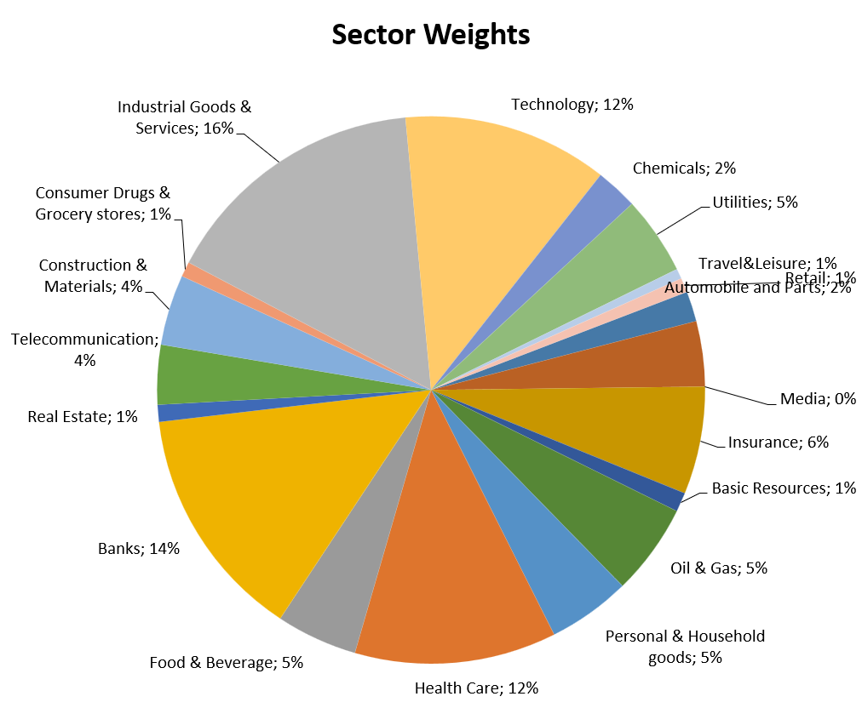
Certificate Terms  Issuer: UBS AG, Zurich  Investment Manager: Aspermont Capital AG  ISIN: CH0473592290  Profile: Tracker-Certificate (SVSP-Code: 1300)  Launch date: December 09, 2019 | ..  Currency: EUR  Denomination: EUR 1000 per Unit  Maturity date: December 09, 2026  Listing: None  (Original launch October 20, 2014)

