AMC Aspermont Dividend Stock Basket
Product update as of April 30, 2026
NAV per share (April 30, 2026): EUR 209.23, monthly performance: +6.11%, YTD: 6.19%, since inception: +108.81%

The Aspermont Dividend Stock Basket
The Actively Managed (Strategy) Certificate (AMC) linked to the Aspermont Capital Dividend Stock Basket provides investors access to a broadly diversified portfolio of around 30 attractive value stocks. We particularly seek out companies with stable or growing dividends and payout ratios, driven by healthy balance sheet structures and sustainable revenue and earnings growth. While screening for such quantitative elements as margin growth, free cash flow and debt-to-equity ratios, qualitative aspects like management performance and corporate strategy are also included in our selection process. A minimum of 80% of the portfolio will be invested in large cap names with market capitalizations of over EUR 10 billion.
Manager’s Comment
In April, the Dividend Basket delivered a performance of +6.11%. With the prospect of a possible agreement that could deescalate the situation in the Middle East, markets rebounded together as the earnings seasons also delivered good results: DAX 7.11%, Eurostoxx 50 5.60%, SMI 2.81%, S&P500 10.42%  In general, we continued with the lower overall USD exposure of around 20%. The USD has been weak in the past months and in April it weakened against the EUR with -1.60%.  In April, one stock stood out – Nokia. Nokia was up 57.4% in our basket. It started the month as a 5.6% position that where we took profit back to 5% at the beginning of the month and ended the month with a 6.9% allocation that contributed 2.5% to the basket. Nokia stock rose in April after strong earnings, booming AI infrastructure demand, analyst upgrades, and optimism around cloud networking growth. The second strongest performed in the basket was Siemens AG, (2.5% position, 22.3% performance) the company rose in April on strong earnings, AI-driven automation demand, positive guidance, and optimism around industrial infrastructure growth. We added a new position at the beginning of April – Siemens Energy (1% starting position) that became the third best performer (+21%) they surged in April after strong earnings, higher profit guidance, grid expansion demand, and accelerating global AI power needs. April showed that industrial companies are delivering strong numbers due to the global AI growth. Schneider Electric, also a 5% position, performed +16.3%, their shares performed strongly in April as investors reacted positively to rising AI-driven data center demand, strong energy management and automation earnings, and growing global investment in electricity infrastructure and efficiency solutions. Morgan Stanley (2.7% position, +12.9% performance in EUR) was the last >10% performer in our basket. The company’s shares rose in April following strong quarterly earnings, resilient investment banking performance, increased trading revenues, and growing investor confidence in capital markets recovery and AI-related technology financing activity.  Deutsche Telekom was our weakest stock in April. (-13.2%) that came under pressure on, currency headwinds and profit taking after a strong performance, and the takeover/merger discussion with T-Mobile with worries about political complications as the German government holds a substantial stake in the company.  Moving into April we expect a recovery, especially in quality titles and are thus not changing our allocation immediately. We continue to look into further quality companies with stable cash flows to invest in. |  | 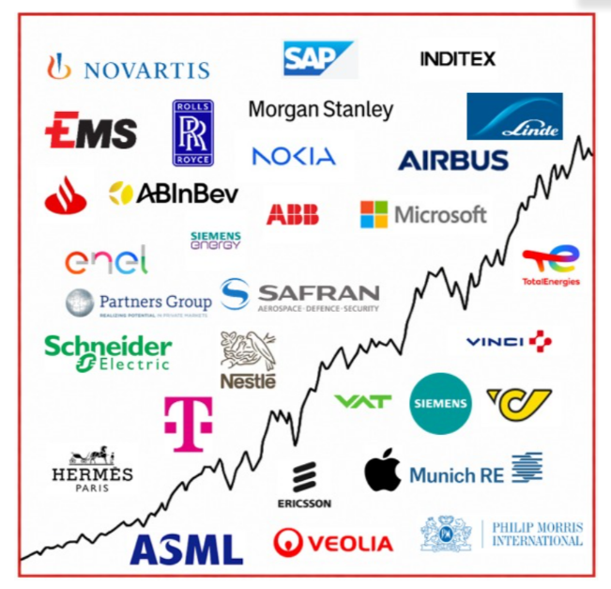  Current Composition (2026)  Performance 12m: Source Bloomberg

Return
 | Jan | Feb | Mar | Apr | May | Jun | Jul | Aug | Sep | Oct | Nov | Dec | YTD
2013 |  |  |  |  |  | -0.45% | 3.76% | -1.26% | 3.13% | 2.37% | 1.85% | -0.45% | 9.18%
2014 | -2.29% | 3.09% | 0.73% | 1.53% | 2.66% | 0.43% | -1.12% | 1.13% | 0.95% | -0.60% | 6.09% | -2.26% | 10.52%
2015 | 7.71% | 0.77% | 5.42% | 2.75% | -1.34% | -4.10% | 3.76% | -8.30% | -0.70% | 3.59% | 1.96% | -3.47% | 8.19%
2016 | -4.97% | -1.93% | 1.56% | 1.94% | 2.69% | 1.36% | 0.22% | -1.65% | 0.46% | -1.04% | -1.31% | 5.31% | 2.29%
2017 | -0.31% | 2.65% | 2.99% | 0.94% | 1.65% | -2.27% | -1.10% | 0.06% | 1.39% | 2.23% | 0.23% | -0.56% | 8.03%
2018 | 0.53% | -2.94% | -1.78% | 3.40% | -0.54% | -0.22% | 4.12% | 0.10% | 0.30% | -6.18% | -0.31% | -8.12% | -12.91%
2019 | 6.88% | 5.52% | 2.43% | 2.52% | -3.48% | 2.06% | 0.51% | 0.41% | 1.15% | -0.27% | 0.67% | 0.22% | 19.79%
2020 | -0.33% | -8.12% | -10.0% | 4.75% | 3.00% | 4.63% | -1.07% | 5.55% | -1.78% | -6.40% | 13.6% | 0.98% | 2.39%
2021 | 0.91% | 1.54% | 5.44% | 0.54% | 1.97% | 3.16% | 0.00% | 1.81% | -3.01% | 5.86% | -0.54% | +3.16% | 22.54%
2022 | -2.59% | -6.62% | -0.23% | 0.0% | -2.74% | -5.63% | 5.96% | -3.64% | -5.71% | 5.80% | 4.61% | -3.81% | -14.59%
2023 | 3.84% | 1.31% | 1.94% | 3.87% | -2.50% | 1.60% | 1.68% | -1.54% | -3.25% | -0.75% | 3.79% | 1.85% | 12.13%
2024 | 1.32% | 3.15% | 2.13% | -1.23% | 1.38% | 1.58% | -0.45% | 1.04% | -0.53% | -1.08% | 1.22% | -2.01 | 6.58%
2025 | 5.39% | 1.98% | -5.58% | -1.84% | 3.56% | -0.97% | -1.25% | -0.94% | 3.08% | 1.20% | -2.30% | 0.18% | 2.02%%
2026 | 2.24% | 5.09% | -6.86% | 6.11% |  |  |  |  |  |  |  |  | 6.19%

Figures & Ratios
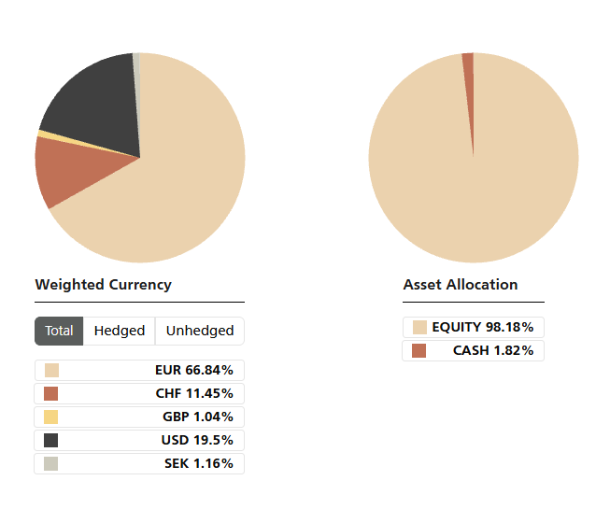
Certificate Terms  Issuer: UBS AG  Advisor: Aspermont Capital AG  ISIN: CH0215884732  Profile: Tracker-Certificate (SVSP-Code: 1300)  Launch date: June 2013 | Currency: EUR  Denomination: EUR 100 per Unit  Maturity: June 12, 2018 (extended to June 13, 2028)  Listing: SIX Swiss Exchange (SIX Structured)

