AMC Aspermont Dividend Stock Basket
Product update as of March 31, 2026
NAV per share (March 31, 2026): EUR 197.18, monthly performance: -6.86%, YTD: 0.07%, since inception: +96.79%

The Aspermont Dividend Stock Basket
The Actively Managed (Strategy) Certificate (AMC) linked to the Aspermont Capital Dividend Stock Basket provides investors access to a broadly diversified portfolio of around 30 attractive value stocks. We particularly seek out companies with stable or growing dividends and payout ratios, driven by healthy balance sheet structures and sustainable revenue and earnings growth. While screening for such quantitative elements as margin growth, free cash flow and debt-to-equity ratios, qualitative aspects like management performance and corporate strategy are also included in our selection process. A minimum of 80% of the portfolio will be invested in large cap names with market capitalizations of over EUR 10 billion.
Manager’s Comment
In March, the Dividend Basket delivered a performance of -6.86%, underperforming the MSCI World EUR (-4.54%). With the escalation of the conflict in Iran, the various indices are all under pressure: DAX -10.3%, Eurostoxx 50 -9.26%, SMI -8.83%, S&P500 -5.09%  In general, we stuck with the lower overall USD exposure around 20%. The USD has been weak in the past months and although March saw the USD strengthen against the EUR with +2.34%, the currency remains weak.  In March, one stock in particular profited from the conflict in the Middle East and the resulting spike in the Oil price – Total Energies that performed 23.91% in our basket with its ending weight of 3.73%. The oil price moved up some 50% considering the constrained supply with tankers not being able to safely pass the Strait of Hormuz. The full extend of the constricted Oil supply is yet to be determined as many countries have built up inventories in the last months making use of the lower oil price. Two more stocks finished the month on a positive note, Nokia and Morgan Stanley. Nokia performed +4.72% and is one of our 5% positions that has grown to 5.58% at the end of the month. Nokia profited due to their defensive nature being in a less cyclical sector and as investors rotated into stable cash flow businesses such as Nokia. Morgan Stanley. Morgan Stanley (+1.19% in EUR terms) as a 2.5% position did well in EUR terms as the USD regained some strength. Even without the exchange rate effect, Morgan Stanley outperformed the market as it profited from investors rotating out of AI and Tech related stocks into financials that has seen a recovery in investment banking and with IPO’s and M&A deals picking up.  Schneider Electric and Safran both were caught in the sell off right after reaching new all time highs prompting investors to take profit on the stock and that accelerated with the start of the conflict surrounding Iran. Similarly, Anheuser Busch just hit a new five year high as profit taking was followed up by the sell off.  Moving into April we expect a recovery, especially in quality titles and are thus not changing our allocation immediately. We continue to look into further quality companies with stable cash flows to invest in. |  | Current Composition (2026)  Performance 12m: Source Bloomberg

Return
 | Jan | Feb | Mar | Apr | May | Jun | Jul | Aug | Sep | Oct | Nov | Dec | YTD
2013 |  |  |  |  |  | -0.45% | 3.76% | -1.26% | 3.13% | 2.37% | 1.85% | -0.45% | 9.18%
2014 | -2.29% | 3.09% | 0.73% | 1.53% | 2.66% | 0.43% | -1.12% | 1.13% | 0.95% | -0.60% | 6.09% | -2.26% | 10.52%
2015 | 7.71% | 0.77% | 5.42% | 2.75% | -1.34% | -4.10% | 3.76% | -8.30% | -0.70% | 3.59% | 1.96% | -3.47% | 8.19%
2016 | -4.97% | -1.93% | 1.56% | 1.94% | 2.69% | 1.36% | 0.22% | -1.65% | 0.46% | -1.04% | -1.31% | 5.31% | 2.29%
2017 | -0.31% | 2.65% | 2.99% | 0.94% | 1.65% | -2.27% | -1.10% | 0.06% | 1.39% | 2.23% | 0.23% | -0.56% | 8.03%
2018 | 0.53% | -2.94% | -1.78% | 3.40% | -0.54% | -0.22% | 4.12% | 0.10% | 0.30% | -6.18% | -0.31% | -8.12% | -12.91%
2019 | 6.88% | 5.52% | 2.43% | 2.52% | -3.48% | 2.06% | 0.51% | 0.41% | 1.15% | -0.27% | 0.67% | 0.22% | 19.79%
2020 | -0.33% | -8.12% | -10.0% | 4.75% | 3.00% | 4.63% | -1.07% | 5.55% | -1.78% | -6.40% | 13.6% | 0.98% | 2.39%
2021 | 0.91% | 1.54% | 5.44% | 0.54% | 1.97% | 3.16% | 0.00% | 1.81% | -3.01% | 5.86% | -0.54% | +3.16% | 22.54%
2022 | -2.59% | -6.62% | -0.23% | 0.0% | -2.74% | -5.63% | 5.96% | -3.64% | -5.71% | 5.80% | 4.61% | -3.81% | -14.59%
2023 | 3.84% | 1.31% | 1.94% | 3.87% | -2.50% | 1.60% | 1.68% | -1.54% | -3.25% | -0.75% | 3.79% | 1.85% | 12.13%
2024 | 1.32% | 3.15% | 2.13% | -1.23% | 1.38% | 1.58% | -0.45% | 1.04% | -0.53% | -1.08% | 1.22% | -2.01 | 6.58%
2025 | 5.39% | 1.98% | -5.58% | -1.84% | 3.56% | -0.97% | -1.25% | -0.94% | 3.08% | 1.20% | -2.30% | 0.18% | 2.02%%
2026 | 2.24% | 5.09% | -6.86% |  |  |  |  |  |  |  |  |  | 0.07%

Figures & Ratios
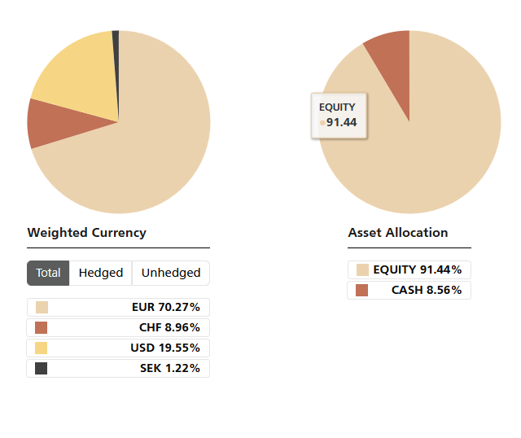
Certificate Terms  Issuer: UBS AG  Advisor: Aspermont Capital AG  ISIN: CH0215884732  Profile: Tracker-Certificate (SVSP-Code: 1300)  Launch date: June 2013 | Currency: EUR  Denomination: EUR 100 per Unit  Maturity: June 12, 2018 (extended to June 13, 2028)  Listing: SIX Swiss Exchange (SIX Structured)

