AMC Aspermont Dividend Stock Basket
Product update as of February 28, 2026
NAV per share (February 28, 2026): EUR 211.70, monthly performance: 5.09%, YTD: 7.44%, since inception: +111.28%

The Aspermont Dividend Stock Basket
The Actively Managed (Strategy) Certificate (AMC) linked to the Aspermont Capital Dividend Stock Basket provides investors access to a broadly diversified portfolio of around 30 attractive value stocks. We particularly seek out companies with stable or growing dividends and payout ratios, driven by healthy balance sheet structures and sustainable revenue and earnings growth. While screening for such quantitative elements as margin growth, free cash flow and debt-to-equity ratios, qualitative aspects like management performance and corporate strategy are also included in our selection process. A minimum of 80% of the portfolio will be invested in large cap names with market capitalizations of over EUR 10 billion.
Manager’s Comment
In February, the Dividend Basket delivered a performance of 5.09%, outperforming the MSCI World EUR (+1.41%) by +3.68%. The month showed a mixed set of performances across the various indices as the earnings season slowly comes to an end with a few select large cap companies reporting at the beginning of March.  In general we kept the lower overall USD exposure around 21%. The USD has been weak in the past months and although February saw a slight change with the USD strengthening against the EUR with +0.46%, the currency remains weak.  In February the three best performing stocks in EUR terms that were 5% overweight positions. Nokia (+21.05 perf., 5.0% position) rose as AI optimism stayed and with that the their strategic partnership with NVIDIA led to several buy rating upgrades by banks and institutional interest supported the stock. Anheuser Busch (15.41% perf., 5.1% position) had a strong month where their earnings release beat analyst expectations with the management commentary showing an upbeat view for 2026. Schneider Electric (+14.22% perf, 5.2% position) also released strong numbers with record revenues and solid growth expectations for 2026. They saw a rapid expansion in AI/data center demand with triple digit growth in data center sales. climbed in January on improved investor sentiment that was supported by major energy deals such as providing renewable power capacity for AI data centers. There were several stocks with double digit growth in February in the basket. Novartis was initially a 5% position, that we reduced to 2.5% towards the end of the month as the anticipation of pharma specific tariffs by the Trump administration increased. Despite that, the stock performed about 13% during the February.  From the two weakest stocks in our basket, one was tech: Alibaba that got under pressure as investors took profit and regulatory and economic uncertainty in China weigh on their sentiment. The stock lost about 15% in EUR term and we reduced it from 5% at the beginning of the month to 1%. Following what seemed like the start of a recovery in December and January, led to a broad sector correction in February (-17.7%) as investors re-evaluated exposures to private credit and tech-sensitive assets. Overall, February was a very strong month for the Dividend Basket. |  | Current Composition (2025)  Performance YTD vs MSCI World EUR: Source Bloomberg

Return
 | Jan | Feb | Mar | Apr | May | Jun | Jul | Aug | Sep | Oct | Nov | Dec | YTD
2013 |  |  |  |  |  | -0.45% | 3.76% | -1.26% | 3.13% | 2.37% | 1.85% | -0.45% | 9.18%
2014 | -2.29% | 3.09% | 0.73% | 1.53% | 2.66% | 0.43% | -1.12% | 1.13% | 0.95% | -0.60% | 6.09% | -2.26% | 10.52%
2015 | 7.71% | 0.77% | 5.42% | 2.75% | -1.34% | -4.10% | 3.76% | -8.30% | -0.70% | 3.59% | 1.96% | -3.47% | 8.19%
2016 | -4.97% | -1.93% | 1.56% | 1.94% | 2.69% | 1.36% | 0.22% | -1.65% | 0.46% | -1.04% | -1.31% | 5.31% | 2.29%
2017 | -0.31% | 2.65% | 2.99% | 0.94% | 1.65% | -2.27% | -1.10% | 0.06% | 1.39% | 2.23% | 0.23% | -0.56% | 8.03%
2018 | 0.53% | -2.94% | -1.78% | 3.40% | -0.54% | -0.22% | 4.12% | 0.10% | 0.30% | -6.18% | -0.31% | -8.12% | -12.91%
2019 | 6.88% | 5.52% | 2.43% | 2.52% | -3.48% | 2.06% | 0.51% | 0.41% | 1.15% | -0.27% | 0.67% | 0.22% | 19.79%
2020 | -0.33% | -8.12% | -10.0% | 4.75% | 3.00% | 4.63% | -1.07% | 5.55% | -1.78% | -6.40% | 13.6% | 0.98% | 2.39%
2021 | 0.91% | 1.54% | 5.44% | 0.54% | 1.97% | 3.16% | 0.00% | 1.81% | -3.01% | 5.86% | -0.54% | +3.16% | 22.54%
2022 | -2.59% | -6.62% | -0.23% | 0.0% | -2.74% | -5.63% | 5.96% | -3.64% | -5.71% | 5.80% | 4.61% | -3.81% | -14.59%
2023 | 3.84% | 1.31% | 1.94% | 3.87% | -2.50% | 1.60% | 1.68% | -1.54% | -3.25% | -0.75% | 3.79% | 1.85% | 12.13%
2024 | 1.32% | 3.15% | 2.13% | -1.23% | 1.38% | 1.58% | -0.45% | 1.04% | -0.53% | -1.08% | 1.22% | -2.01 | 6.58%
2025 | 5.39% | 1.98% | -5.58% | -1.84% | 3.56% | -0.97% | -1.25% | -0.94% | 3.08% | 1.20% | -2.30% | 0.18% | 2.02%%
2026 | 2.24% | 5.09% |  |  |  |  |  |  |  |  |  |  | 7.44%

Figures & Ratios
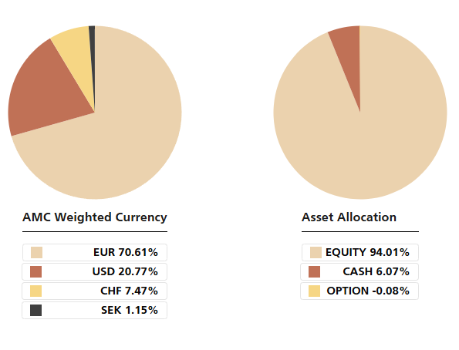
Certificate Terms  Issuer: UBS AG  Advisor: Aspermont Capital AG  ISIN: CH0215884732  Profile: Tracker-Certificate (SVSP-Code: 1300)  Launch date: June 2013 | Currency: EUR  Denomination: EUR 100 per Unit  Maturity: June 12, 2018 (extended to June 13, 2028)  Listing: SIX Swiss Exchange (SIX Structured)

