Market Monthly
February 2026
Highlights
- Economics Global equities ended on a positive note in January. In the US, the advanced reading of the annualized GDP for 4Q25 came in lower than expected (2.8%) and previous (4.4%) at 1.4%. The unemployment rate for December came in at 4.3%, lower than the revised previous of 4.4% and expected 4.4%. Final US Manufacturing PMI for January came in at 52.4, as expected and revised previous. Services final January numbers was 52.7, above the expected 52.5 and the revised previous of 52.5. In Europe the YoY advanced reading GDP for 4Q25 came in at 1.3%, the same as the previous quarter. Eurozone aggregate unemployment for December was lower than expected and previous at 6.2% vs 6.3%. PMI numbers for final January were as follows: manufacturing 49.5 above previous 48.8 and expected 49.4; services 51.6 below previous 52.4 and expected 51.9.
- Inflation: January CPI in USA was 2.4%, lower than the expected 2.5% and the revised previous of 2.7%; the preferable FED measure, core price inflation (PCE) YoY was now published for December at 3.0%, higher than the previous reading of 2.8%. Eurozone inflation for final January came in at 1.7%, (1.7% expected, 1.7% previous). Inflation figures in other economies were as follows: China 0.2%, India 2.75%, Brazil 4.44%, Russia 6.00%
- Central bank interest rates: In the first FED meeting of 2026, the rates were left at their current level with the upper bound rate at 3.75%. The next meeting is scheduled for March 18, 2026. As for the ECB, their second meeting of 2026 will take place March 19, 2026 and the current main refinancing rate is at 2.15%.
- Capital market rates: During the month of February, the yield on the 10Y Treasuries moved down to 3.94% from 4.24% and the general USD yield curve shifted up ever so slightly on almost all maturities. In the 10Y Bund, the general curve moved down with 10yr maturity at 2.64% from 2.85%.
Tactical Asset Allocation
- Forex: The USD weakend against the EUR and at the end of the month noted at 0.85 EUR/USD up 0.46%.
- Bonds incl. High Yields (N): So far, our view with peak of yields on US Treasuries in April of last year still holds. Currently fixed income rebalances should be done to utilize the still high yield environment. USD yields have not moved much, but pressure and expectations continue that yields come down.
- Equities (O): December was in general a positive month for the individual markets, with the US markets S&P500 down
-0.87%; Dax up +3.04%; Eurostoxx 50 up +3.20% and the SMI up +6.26%.
- Commodities (O): Crude oil had a good month in February going from $65.21/barrel to $67.15/barrel (+2.78%), with the various conflicts still ongoing. Gold continued on a positive note in January ending at $5’277.44/oz (+7.98%).
Investment Ideas
- Our exposure in equities remains reserved and we are focused on taking opportunities as governments start negotiations.
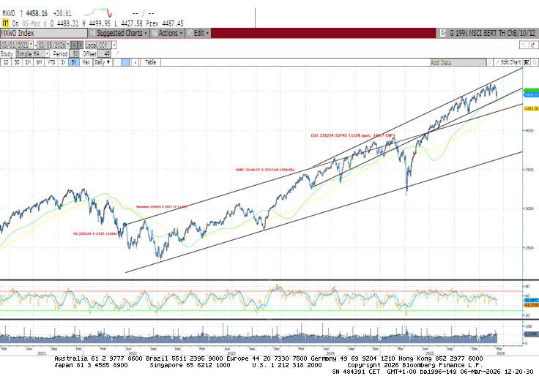
Performance Equity Markets MSCI World 5Y

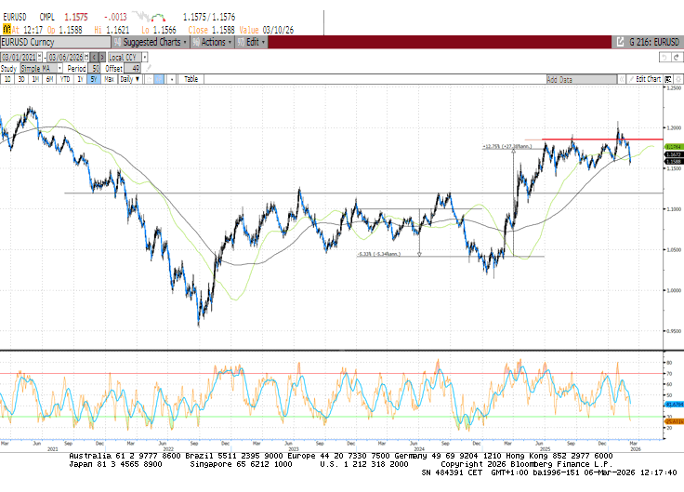

EURUSD Technical Chart 5y, Bloomberg

How to read: (U) underweight; (N) neutral; (O) overweight

