Market Monthly
September 2020
Highlights
- Economics: After reaching historical Maximum on 2nd September (3,588.11), S&P had declining trend until end of month (-3.9% in September), general opinion of overheating tech stocks resulted in decline of NASDAQ 5.2% in September. Observing economic activity, US GDP declined 31.7% in Q2 2020, it is estimated that it will rebound 34.6% in Q3 2020 and 3% in Q4 2020. Coronavirus and upcoming elections were the major topics in September. New corona stimulus package is not achieved yet, Democrats and Republicans are negotiating about the actual amount, sides agree that additional stimulus is needed to incentive consumption, induce inflation, and decrease unemployment (7.8% in September). Corona cases in USA stagnates, while infection rate is increasing in Europe. Unemployment rate in Eurozone increased a bit to 8.1%, Germany value is slightly lower (6.2%) during September. There were no additional coordinated economic measure beside already approved 1.35tn euros. Confrontation between China and USA settled down during last month, resulting with low volatility on Chinese markets. Latest release of dollar denominated exports showed 17% decrease Y-o-Y, while imports decreased 13.1%. Slowing down of trading could be interpreted as stagnation of domestic consumption, and conflict with China, which can limit potential growth of equity market.
- Inflation: USA CPI in August climbed by 0.4% reaching a 12 month figure of 1.3%, but still below targeted 2%. Core inflation in Europe decreased by 0.6% and now annual value is negative, -0.2%. Other 1Y CPI values for August were: Russia 3.0%; China 2.4%, Brazil 2.4%, India 6.7%
- Central bank interest rates: In its latest meeting, FED kept current interest rate corridor (0% to 0.25%) and demand more fiscal stimulus to achieve its inflation target. Other monetary authorities, like ECB and People’s Bank of China kept rates at -0.25% and 3.85% respectively.
- Capital market rates: FED announcement in August pushed yields on 10Y treasuries to 0.7%, after that bond price was not changed. German Bund posted additional 10bps decrease in September, with final yield value of -0.53%
Tactical Asset Allocation
- Forex: After reaching 2Y low of 1.20 to euro, dollar start to appreciate, mostly driven by decrease on equity market. End of September spot value to euro was 1.17.
- Bonds incl. High Yields (U): Since near-zero/negative policy rates and negative real rates are seen persisting in Europe for several years, we continue investing in up to 2028 maturities of European DM bonds to improve yield and look for USD bonds with shorter maturities.
- Equities (O): Expected correction on tech stocks happened in beginning of the month, dragging down other sectors, but not in full extent. In our opinion, investing in defensive stocks like pharmaceuticals and finding oversold companies in oil sector can be attractive.
- Commodities (N): Similar to August movements, oil price was traded in tight range $37-41/barrel, keeping equilibrium between downside pressure from lack of demand, and, on the other side, reduction in supply from typhoon seasonality in USA.
Investment Ideas
- We continued to write call options on stocks from overperforming sectors, and invest excess of cash to buy market dips in selected stocks from IT, oil and pharma sectors.

Performance Equity Markets MSCI World 12m
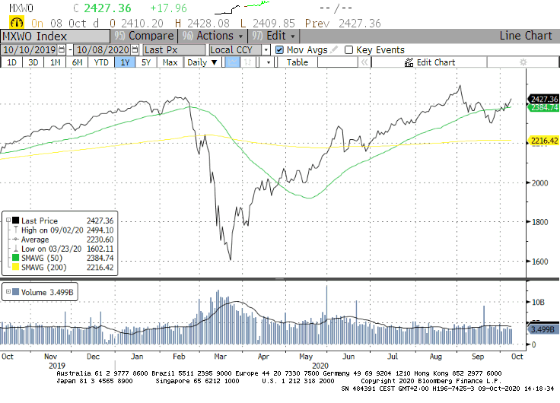

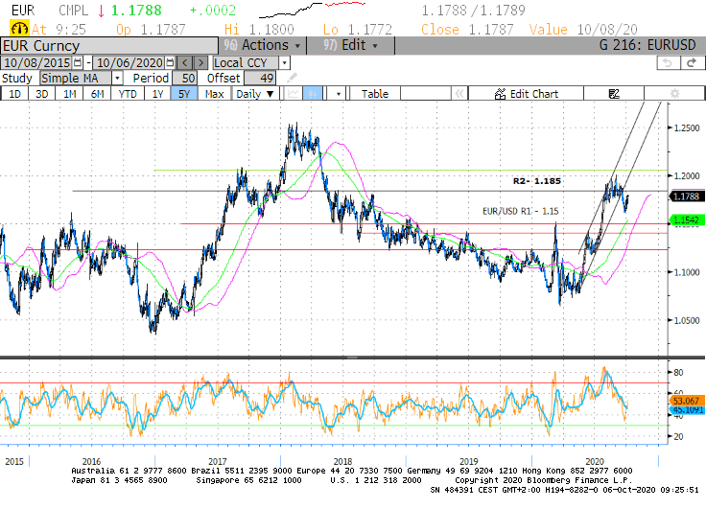
EURUSD Technical Chart 5y, Bloomberg

How to read: (U) underweight; (N) neutral; (O) overweight
See rationales on our web page www.aspermontcapital.ch
Return for the last rolling 12m

