Market Monthly
April 2020
Highlights
- Economics: First quarter GDP numbers across the worlds showed sharp reverse in economy activity. In USA, GDP decreased by 4.8%, with cumulative number of jobless claims totaled to 26mn. Massive fiscal stimulus which exceeds USD 2tn coupled with FED expansive monetary policy will offset part of coronavirus adverse impact on Q2 but still US economy will most likely post two consecutive quarters of decline. Same situation is in Europe where GDP fall by 3.8% in Q1, where the expectation for whole year are -7.4%. According to released figures and outlooks, China already faced worst consequence of coronavirus with -6.8% GDP drop in 1Q, but stated that overall growth for 2020 will be 5%.
- Inflation: Observing US consumer prices on monthly basis, expenditures declined by 0.4% in March, reaching 1.5% increase for y-o-y. On Eurozone, prices in March dropped by 0.5% comparing to February, 12 month figure is 0.7%. Other 1Y CPI values for March were: Russia 2.55%; for China 4.3%, Brazil 3.3%.
- Central bank interest rates: Central Banks around the world had same response to financial crisis happened in March, slashed the interest rates and pledged historical high asset purchasing programs. FED and ECB didn’t change key interest rates, which remains 0% and -0.5% respectively, while Chinese Central Bank further decrease it by 20bps to 2.95%.
- Capital market rates: Volatility and demand on bond market was cooling down in April. Rebound on equity market alongside with predictable monetary response made 10Y US Treasuries to trade in narrow 0.6-0.8% range in April. 10Y Bund changed hands in slightly wider corridor but still with negative yields between -0.25% and -0.6%.
Tactical Asset Allocation
- Forex: After two months of strong movements in both direction, EUR/USD pair is stabilized in 1.08 – 1.10 range, ending month on upper bound. While monetary response was to some extent higher in US, Euro is facing depreciation pressures from lack of political consensus for coronavirus measures, so overall impact is neutral.
- Bonds incl. High Yields (U): Since near-zero/negative policy rates and negative real rates are seen persisting in Europe for several years, we continue investing in up to 2028 maturities of European DM bonds to improve yield and look for USD bonds with shorter maturities.
- Equities (O): Bull-run on global markets started in third week of March, continued on April where S&P recovered 12.5%. DAX also posted almost double digit growth, but Eurozone markets are still trailing Americans by significant margin. Difference between performances of those two indices is 8%, observing from the beginning of the year.
- Commodities (U): After fiasco of OPEC+ meeting in March, increase in supply coupled with decrease of demand pushed futures on May oil contracts into negative territory for the first time in more than 100 years history for brief period. However, agreement between Russia and Saudi Arabia for cutting production starting from 1st May helped to recover price, which is $20/barrel on end of the April.
Investment Ideas
- Markets around the world recovering from virus impact, so we decreased cash position and overweight Chinese equities because most of restrictions related to containing spread of corona are already lifted in China.

Performance Equity Markets MSCI World 12m 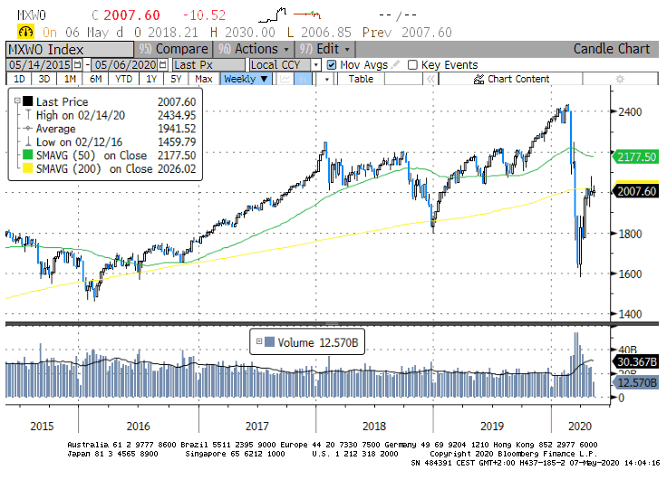

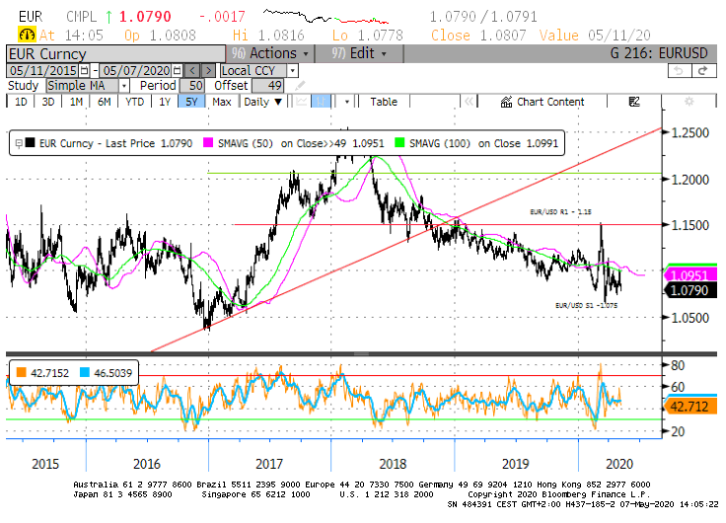
EURUSD Technical Chart 5y, Bloomberg

How to read: (U) underweight; (N) neutral; (O) overweight
See rationales on our web page www.aspermontcapital.ch
Return for the last rolling 12m

